Autumn 2019

~2351 Durham Road, Guilford, CT ● 203.457.0770 ● www.dudleyfarm.com~

Mission Statement
"To preserve, restore, and operate the farm as a historical, educational, and recreational
resource for the public.’’

President’s Corner
A Message from Bill Black

Well, that old adage 'I can see the light at the end of the tunnel' is very true. By the time you get this newsletter the Big Barn Project (BBP) will have concluded. In addition to the BBP the milk house and ice house/public bathrooms will be up and operational.
With these projects up and running the Farm will be able to expand the space available to display its vast collection of agriculture items. And with this expansion, the Farm can now move into its next phase—maintaining the quantity and quality of our display items along

with providing visitors with a world-class museum. With this vision in mind, the Board of Directors has been looking into ways to accomplish this goal. The best solution is to create an endowment fund that will provide needed income on an annual basis enabling the Farm to continue its success story.
In the past, the generosity of individuals, corporations, and foundations have provided all the funds necessary to complete the BBP, the milk house and the ice house/public bathrooms. Now with their completion comes the added annual expense to maintain each of them. As mentioned before setting up an endowment fund would be the answer. But that's the easy part. The difficult part is getting the money to put into the endowment fund. With this in mind, the Board is exploring a number of ways to make this a reality. An article by our treasurer, Laurie Caraway, appears later in this newsletter and outlines a number of fundraising thoughts.
In the past, The Farm has been fortunate to be named a beneficiary in several wills. This money went a long way to reaching our construction goals. And, of course, if you or someone you know is thinking of leaving a portion of their estate to The Dudley Farm we are always grateful and willing to help make it a reality. And what better way than to see your hard-earned money be used for something which will not only benefit the entire Guilford community but everyone coming here from beyond our borders. And this benefit is not just a one-time occurrence but will keep on giving year after year. The virtue of helping future generations learn and explore the past on a

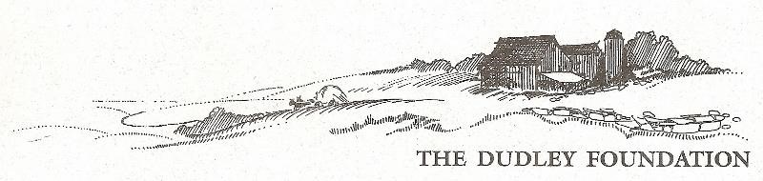
Officers and Directors
President – Bill Black
Vice-President – Janet Dudley
Treasurer- Laurie Caraway
Assistant Treasurer – Bill Black
Recording Secretary – Jerri Guadagno
Corresponding Secretary – Dorothy Crampton
Board Members – Bob Guadagno, Ray Guimont, Don Homer, Kendrick Norris, Tom Leddy, Jim Powers, Doug Williamson, Buster Scranton
Museum Director – Beth Payne
(director@dudleyfarm.com)
Newsletter Staff – Bill Black, Ray Dudley, Beth Payne
Website – www.dudleyfarm.com
Facebook - www.facebook.com/dudleyfarmmuseum
Email – info@dudleyfarm.com
Dudley Farm Office – 203-457-0770
The Dudley Foundation is a 501 (c)(3) non-profit organization and contributions are tax deductible.
hands-on basis is something that can't be easily measured. Maybe there's a young potential scientist out there who will someday visit the Farm and later realize their future dreams and expectations started with a visit to The Dudley Farm Museum.
Now that would make everything we do here at The Farm worthwhile.

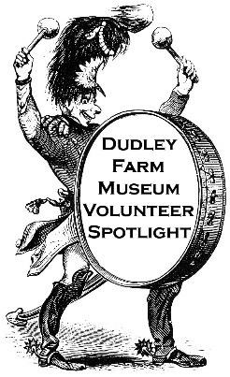
Volunteer Spotlight
Jim Powers

One must only drive by or visit The Dudley Farm during the weekly Farm Market this past year to see there has been an enormous amount going on – building wise. The Big Barn Project is nearing completion and the long-hoped-for recreation of the Milk House building now stands in front of the Big Barn. The Icehouse that will house bathrooms for visitors to the Farm, as well as a display of ice harvesting equipment, has also been recreated. The Milk House and Icehouse are both located on the sites of those originally on the Farm.
The person most responsible for all three projects is Doug Williamson, one of the original founding members of The Dudley Foundation and a tireless volunteer whose vision and determination have brought these and many past projects to life. Doug, along with other founding member, Don Homer, are the Farm’s Building Committee responsible for putting together the plans for the three recent projects.
Doug has not only done the design work; he has found the contractors who have done much of the work and has been intimately involved overseeing the work on each project. The Dudley Farm you see today and well into the future is a reflection of Doug’s vision and efforts. We all owe Doug a well-earned thank you. If you see him around the Farm, let him know you appreciate all he has done.

Buster’s Musings
Buster Scranton
Evolving into the Dudley Foundation

Twenty-five years ago, on October 10, 1994, the Dudley Foundation became incorporated, and the unforeseen and improbable journey to becoming a museum and destination began. Nobody saw it coming; North Guilfordites were in the dark about the details of the local landmark. The North Guilford Congregational Church and the North Guilford Volunteer Fire Company were both unsuspecting beneficiaries of David Dudley's will. At the time, it seemed that the two entities would just be financial recipients of David's estate after the real estate and contents were sold.
Realizing the unique character of The Dudley Farm, several long-time locals, primarily from the fire company, wondered if it would be possible to preserve this gem to make it a community resource. It required a lot of cooperation--the fire company supported the concept but did not wish to run the farm, and the church felt likewise but needed to protect the church's interests. It was a daunting task, but numerous outside people and entities worked to make it happen. The Town of Guilford Probate Court, tasked with settling the estate, was a key partner in finding a way to achieve this goal. Attorney Bill Aniskovich went way over the top with the legalities of tax and incorporation matters, areas which were far beyond the capabilities of the rest of us involved.
From the outset there were many who pitched in, all bringing their own set of skills. I’m sure I will miss some, but Henry and Evelyn Tichy, and Bob and Lorraine Ashman were so involved in the physical and clerical duties of a property desperately needing attention. Bill and Peggy Barnes were also dedicated to the Foundation's success while enjoying the friendship of all involved. There are still people at the farm who started from day one; Bob and Jerri Guadagno, Don Homer, Janet and Mark Dudley, Doug Williamson, and I have all been around for a while.
Where to start? In this case, it was clean up, a job that continues to a lesser degree today. Care was taken to separate the trash from the treasures, both of which were abundant. One scrap metal run, with Ray Dudley and his truck, even did better than break even. The whole place was a mystery to all who passed by every day, so we decided to have an "open house" so that the public could satisfy their curiosity. Judging by the attendance, there were a lot of curious people and a lot of goodwill.
The buildings and grounds have been money pits, with sills and roofs, and everything in between, needing attention. We have managed to upgrade the electrical enough to keep the place from burning down, and nobody has to use the hand pump at the kitchen sink anymore. Best of all, the outhouse is no longer in use! Most everything (but not everything) is structurally sound now, and roof and painting projects will in the future be regularly scheduled events, not emergencies.
Of course, we needed a coherent plan, and so it was decided that the museum would focus on the years around 1900. This was important when we produced the book Voices from North Guilford, although our writings included some events from other times for perspective. Concentrating on a narrow era makes it easier to plan our events, and to accept or reject donation items. Cooperation with the Guilford Land Conservation Trust has resulted in a substantial conserved parcel, available for the public to enjoy.
A lot has happened, and it shows! Guilford Rotary reconstructed our Sugarhouse, so we now have a successful maple program in late winter. A Farmers’ Market has been established, reputed to be the second oldest one in Connecticut. The Dudley Farm String Band has faithfully provided event music for a number of years-- what other market has that! The farm animals are a favorite attraction for all ages, thanks to the stewardship of the Dudley's. Gardening, both for ambiance and food production, keeps the grounds good looking and productive. The museum is a step back to a different way of living, circa 1900. And the Munger Barn, moved from Madison and reconstructed under the guidance of George Senercia, has been a great venue since 2003. These days, a lot is going on. The Big Barn restoration is completed, and it has been a major undertaking. Also finished are the Milk house and Ice house/restrooms.
All of this has been the result of a vision, and a lot of hard work. Our volunteers and our members continue to make it all possible.

October is Membership Renewal Month

The Dudley Foundation has just completed 25 years! come a long way – and have a long way yet to go. Won’t you be a part of it by renewing your membership today?
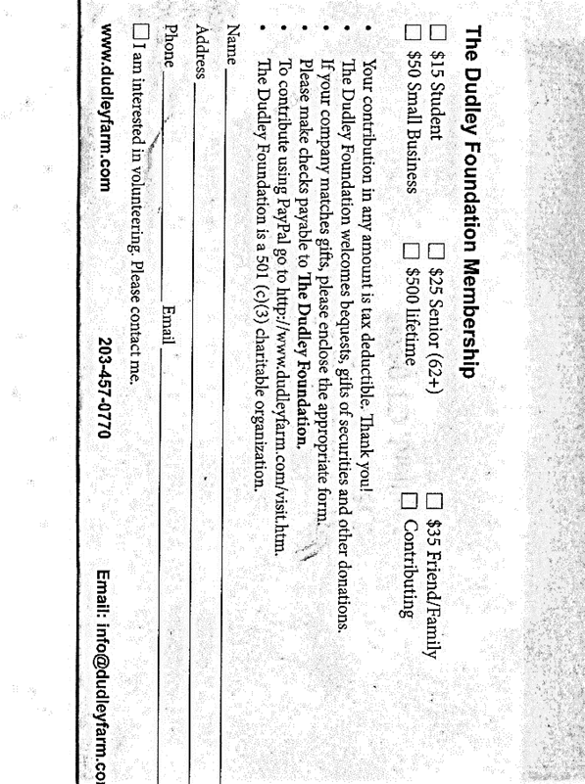
The 19th Century
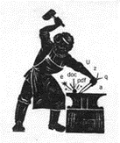
Wordsmith
Beth Payne

“Words aren't made — they grow,' said Anne.”
― L.M. Montgomery, Anne of the Island (Anne of Green Gables)

“Books serve to show a man that those original thoughts of his aren’t very new after all.” – Abraham Lincoln

The 19th century saw Americans struggling with the notion of what it meant to be an American. A time of profound and accelerated change, industrialization, urbanization, and the emergence of new technologies and scientific discoveries all meant that the realities of daily life changed markedly between 1800 and 1900. Education and literacy, both somewhat limited in 1800, improved with public‐school (through grade 8) enrollment doubling between 1870 and 1900. The growing middle-class increasingly sent their offspring to high school, while the growth in elementary education reflected the influx of immigrants who wanted their children to go to school as a means of getting ahead. Meanwhile, educators and public officials saw schools as the best instruments for acculturation into American society. Revolutions in printing technology meant that books and newspapers could be produced faster—and more cheaply— allowing for a rapid spread of ideas.
The invention of the telegraph has been described as the nineteenth-century equivalent of the internet; for the first time, language could be transmitted—at unprecedented speed—without the need for face-to-face interaction. Fast long-distance communication became a reality, with Western Union building its first transcontinental telegraph line in 1861. The introduction of the telephone (which quickly generated its own verb to telephone) presented similar opportunities for spoken language; direct speech no longer required the physical presence of the speaker in the same room as the person or persons being addressed. (n.b. North Guilford had telephone service by 1909 – but only those with generators had electricity.)
But what about the written word? Was there consensus building over the spelling and meaning of an increasingly American form of English?
Samuel Johnson’s Dictionary, written in England in 1755, was in general use in America, but America's two great nineteenth-century lexicographers, Noah Webster, and Joseph Emerson Worcester, argued fiercely over Johnson's legacy. In 1789 Webster declared that 'Great Britain, whose children we are, and whose language we speak, should no longer be our standard; for the taste of her writers is already corrupted, and her language on the decline.'
Webster (1758 to 1843) was at times a failed farmer, an uninspired teacher, a state representative, a co-founder of Amherst College, a copyright advocate and a friend of George Washington, as well as a fiercely patriotic Federalist. And he was enthusiastic about spelling reform. We have him to thank for Americanized spellings of ‘favor,’ and ‘theater’ and ‘defense'” as well as the word “Americanize” itself.
No wonder Webster saw his publication of his American Dictionary in 1828 as more than a convenient reference; he regarded its contributions to standardized language usage and spelling as integral to building a new nation. A pioneer in many fields, his dictionaries, spellers, and copious writings were part of America’s cultural revolution. In 1847 (four years after his death), George and Charles Merriam gained the rights to Webster’s work and published their first edition of the dictionary in Springfield, Massachusetts. Selling for a then-hefty $6 per copy, the dictionary met with wide popularity, a feat made possible by modern printing techniques, ensuring Noah Webster’s legacy as the father of the American English language and a creator of the national identity.
The Dudley Farm has an 1893 leather-bound edition of Webster’s Unabridged Dictionary. Fully 8 ½ by 11 inches in size and 3 ½ inches thick, it begins with a 12,000-word table of synonyms. With education prized by the Dudley family, one can be assured that among their many books such a dictionary would have been well-used.
But now it’s twilight time for printed dictionaries, whose word-filled bulk weighed down desks, held open doors and by turns inspired and intimidated writers searching for the perfect word. Lexicography — the making of dictionaries — has gone digital. Though a few are still published, the dictionary’s time as printed, bound document is almost up.

Notice of Annual Meeting and Call for Nominations for the Board of Directors and Officers

The Annual Meeting of The Dudley Foundation and Pot-Luck dinner will be held on Thursday, October 17th at 6:30 pm. The Nominating Committee presents the following slate for the Officers and Board of Directors for next year.

Officers: (1-year term from October 2019 to October 2020)
President: Bill Black Vice President: Janet Dudley Secretary: Jerri Guadagno Corr. Sec.: Dorothy Crampton Treasurer: Tom Cost Ass’t Treasurer:Bill Black

Board of Directors (3 years term October 2019 to October 2022)
Laurie Caraway (2019-202 Tom Cost (2019-2022) Bob Guadagno (2019-20220 Jerri Guadagno (2019-2022) Tom Leddy (2019-2022)
Continuing Board Members:
Bill Black (2017-2020) Janet Dudley (2017-2020) Kendrick Norris (2017-2020) Oliver Scranton (2017-2020) Donald Homer (2018-2021) Ray Guimont (2018-2021) Jim Powers (2018-2021) Doug Williamson (2018-2021)

If you are interested or know someone interested in volunteering to help guide and run our operations, please contact our office at 203-457-0770 or email director@dudleyfarm.com. And of course, nominations are accepted from the floor during the Annual Meeting.
Perhaps you are not interested in joining the Board, but would like to contribute in some other ongoing way (there are lots of jobs needing to be done!) - Let us know and we'll pass on your name to the appropriate Committee.
Agenda for the meeting:
1) Welcoming of new and returning members 2) Reports on the activities of the organization in the past year 3) Presentation of the annual reports 4) Presentation by Nominating Committee 5) Election of new Officers and Directors 6) We are excited to have a guest presentation by Grace Belanger, Assistant Manager of Visitor Services at The Mark Twain House in Hartford. Grace is deeply involved in that museum's education program and a delightful speaker on the general topic of Mark Twain, his house, and his life in Hartford.

You are invited to bring a dish to share as well as your dishware and flatware. Enjoy the company of your fellow members and make 2020 another banner year for The Dudley Foundation!

The Dudley Farm Museum Wish List

Calling all Volunteers!
Archives: We have items to accession and items to add to our collection database. Would you like to help to evaluate, describe, and enter information into our museum software? Call us!
Buildings and Grounds: Volunteers are needed to help with the upkeep and improvement of our buildings and their landscapes. Lend us your green thumb and get involved! Perhaps you would like to help with the gardens which surround the house. They need some tender loving care!
Publicity: The Dudley Farm Museum needs volunteers with writing and graphic design experience to create flyers, ads, postcards, and press releases. Other volunteers may help us prepare mailings or distribute publicity materials as needed to promote upcoming events. Help us get the word out!
Event Planning: Our celebrations and programs require the help of many people. Do you have event planning experience? Are you good at managing special projects?
Gift Shop and Quilting: As you may know, the Dudley Farm Quilters work year-round to keep our Gift Shop stocked with handcrafted quilted and needle worked products. But they could use some help. Would you be interested in managing our Gift Shop? Or joining our quilters?
Education: Do you enjoy history and want to know more about North Guilford during the 19th-century? Maybe you like conveying your knowledge to young and old. We have a spot for you. We can always use docents, who get to learn so much about the happenings of the late 19th-century, but we also need someone interested in reaching out to our younger folk. Interested? Please let us know. And we hope to see YOU down on the farm!

The Dudley Farm Recipe Box
Beth Payne
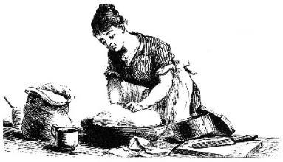
Dining together as a family has become increasingly difficult with today’s rapidly increasing demands and hectic schedules. Many dinners now include fast food or carry out delivery from the local pizzeria. When families do have time to prepare a meal, it is rarely “from scratch.” Technologies that we often take for granted—such as microwaves and refrigerators—have greatly affected what we eat and how we eat it. While today’s meals are planned around the family’s schedule, this was not the case for Martha Dudley or any of the women living in North Guilford during the late 1800s. Indeed, most families planned their daily schedules around the family’s meals. Cooking dominated the time and energy of the average housewife. There was no Big Y – and B.C. Dudley’s General Store on County Road had limited foodstuffs available. Most fruits and vegetables were grown on the farmstead, and local families processed their own meats which included poultry, beef, and pork. The seasons dictated what there would be for dinner, with more fruits and vegetables harvested from the kitchen garden eaten in the spring and summer, while canned and dried foods would be featured during the colder months. Think baked beans and dried apples; families found ways to preserve their food. The three main ways of curing foods during this time were drying, smoking, and salting. While salt cod and dried beef were staples to North Guilfordites of 1900, and still enjoyed by some, few millennials have ever tasted these now-expensive commodities. Curing methods drew moisture out of foods to prevent spoiling, while fruits and vegetables could be dried by being placed out in the sun or near a heat source. Today inexpensive food dehydrators can be had for home use, and they have a loyal following. Meat products were preserved through salting or smoking, and sometimes canning. A salt cure involved rubbing salt into the meat, which was then completely covered in salt and placed in a cool area for at least twenty-eight days. During this time, more salt was constantly added. When the meat was no longer damp, it was washed, then shelved or bagged and left to age. Families would hang meat preserved through a smoke cure in rooms or buildings with fire pits. For a month, the meat was constantly exposed to smoke, which dried it out while adding flavor. Using different kinds of wood for the fire, such as hickory or oak, could produce different tastes. Indeed, there was a smokehouse on The Dudley Farm during this period. Nathan Dudley wrote an essay in 1897 while a student at Cornell which talked about a typical day of farming during harvest season. His mother, Martha, rose early and built the fire in the cookstove based on the meals planned for that day, with breakfast served after morning chores were completed, around 8 AM. The kitchen was often hot, smoky, and smelly, and there was more to do than just starting a fire for cooking. Spices, such as nutmeg and cinnamon, and seasonings, like salt and pepper, had to be ground up with mortars and pestles. Milk had to be brought in from the family cow and cream and butter made. Milk often sat out for about an hour before being used once it was brought into the house. The cream rose to the top, which could then be placed into a butter churn to be made into butter. Clearly, meal preparation involved several more steps than it does now. As with most of our families today, families usually ate three daily meals. The main meal, dinner, was enjoyed in the early afternoon, while supper was a smaller meal eaten in the evening. For modern families, food and meals are often merely an afterthought in the schedule, with food and food preparation no longer standing at the center of the family’s daily lifestyle. Wood stoves began replacing hearths for home cooking in the mid-19th century, but their popularity was short-lived, with gas stoves, which were easier to control, appearing in the 1890s, followed by electric stoves in the mid-20th century after electricity became available (around 1936 for North Guilford.) But the wood stove as a cooking device (many were designed to burn coal as well) was not immediately embraced by cooks of the day, who were accustomed to recipes written for open-hearth methods. Harriet Beecher Stowe once said that men would never go off to battle if all they had to return to was a big ugly piece of iron. None-the-less, there are still those who contend that there is something magical about food prepared in an oven fueled by wood. Few of the wood or coal burning stoves manufactured today come equipped with ovens, but those with flat tops can be used for all sorts of cooking normally done on gas or electric ranges (as some of us know who have lived through winter storms without electricity!) On a wood stove one regulates the stovetop heat by moving pots from the center, where the heat is most intense. Wood stoves were, and still are, ideal for long-simmering stews, soups and stocks. So put aside the microwave, fire up the woodstove, and make a pot of coq au vin this fall and think about cooking this way every day. While you won't regret it, you will be happy that you need not do this every day!

The Quilters’ Corner
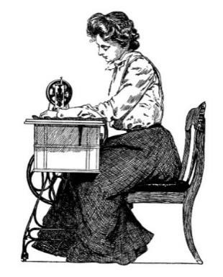
Jerri Guadagno

If you come to the Farmers' Market, you will see all the needlework we have for sale at our Gift Shop table. Two of our newest additions are an infant and small baby bibs, for those teething years, beautifully made by a young high school student. Our second must-have item is our feedbag shopping bags. If you are concerned about plastic in our environment, this is the way to go, they are strong and will last for years. While you are at the Market make sure to stop at our Gift Shop table, and purchase a raffle ticket for our newest queen-size raffle quilt for just $1.00. See you soon.

The Dudley Farm Gift Shop
Jerri Guadagno

The Farm is looking for a volunteer to manage our newly renovated gift shop that will open in our recently restored Big Barn. All of the items we sell will be continually stocked by the Dudley Farm Quilting Group which is responsible for our yearly quilt. The gift shop is open at the same time as the Farmers’ Market, Saturdays from 9:00 AM until 12:30 PM.
If you have some extra time to volunteer, please help us out and join a great group of Dudley Farm volunteers. You won’t regret it.
Give us a call, you will have a great time. Call: 203-457-0770.

Miss Manners for the 19th Century

Beth Payne
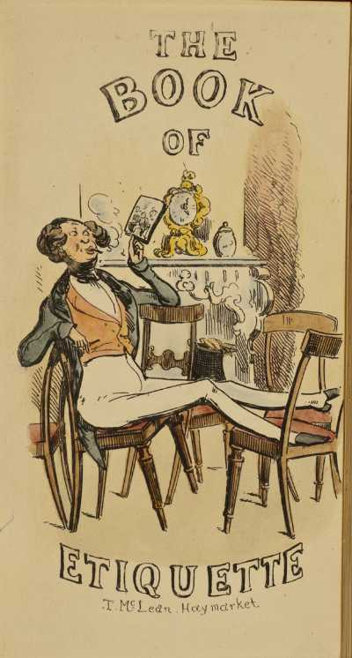
During the 19th century, etiquette and behavioral manuals were big business. These publications served to guide people toward “proper” behaviors that should be displayed in everyday life. After all, it was often said: "good manners are to the family, what good morals are to society; - their cement and their security." (The American Pure Food Cook Book and Household Economist, 1899). It was these manuals that guided everyday folk who wished to emulate the behavior of upper classes which was viewed as the ultimate symbol of refinement and ‘good breeding’. While these guides centered on etiquette, they frequently advised about moral behavior with detailed descriptions as to the consequences of not following those proscriptions. Such is the 500-plus page text with the intriguing title: Safe Counsel: Searchlights on Health: Light on Dark Corners: a complete sexual science and a guide to purity and physical manhood: advice to maiden, wife, and mother, love, courtship and marriage. Written by Prof. B.G. Jefferis, M.D., PH.D. Dr. Jefferis was a Canadian doctor and prolific writer who trained and practiced in the United States. First published in 1885, our Museum has the 1904 edition. The many illustrations include many really lovely pen-and-ink drawings, photographs, and diagrams, including some more in keeping with the physiology being described, including human sexuality. By the way, this publication was only available by subscription and went through 43 printings. One wonders, did it come in a plain brown wrapper? The introduction to the book declares:
KNOWLEDGE IS SAFETY. 1. The old maxim, that Knowledge is Power, is a true one, but there is still a greater truth: KNOWLEDGE IS SAFETY. Safety amid physical ills that beset mankind, and safety amid the moral pitfalls that surround so many young people, is the great crying demand of the age. 2. CRITICISM. --This work, though plain and to some extent startling, is chaste, practical and to the point, and will be a boon and a blessing to thousands who consult its pages. The world is full of ignorance, and the ignorant will always criticise, because they live to suffer ills, for they know no better. New light is fast falling upon the dark corners, and the eyes of many are being opened.
With Excerpts from Well Known Authorities
"Vice has no friend like the prejudice which claims to be virtue." Lord Lytton. "When the judgment's weak, the prejudice is strong." Kate O'Hare. "It is the first right of every child to be well born."
Topics discussed include: Personal Purity; How to Cure Pimples or Other Facial Eruptions; What Women Love in Men; The Advantages of Wedlock; The Disadvantages of Celibacy; Old Maids; Flirting and Its Dangers; Shall Pregnant Women Work?; How to Cure Apoplexy, Bad Breath and Quinsy (Quinsy, also known as a peritonsillar abscess, is a rare and potentially serious complication of tonsillitis.); Immorality, Disease, and Death; Object Lessons of the Effects of Alcohol and Smoking. Readers are also advised:
“Never go up and down stairs, or about the house, with the speed of a trotting horse and the tread of an elephant; step lightly, quickly and orderly.”
“Inquisitive persons are exceedingly annoying, both at home and abroad.”
“The reputation of being a flirt is to be dreaded by young ladies, for their company soon becomes annoying to men of sense; while those who possess similar tastes will never ask them to be admitted to a nearer and dearer companionship. And a gentleman flirt is one of the most despicable creatures in the whole creation!”
“Never gesticulate in everyday conversation, unless you wish to be mistaken for a fifth rate comedian.”
“Avoid gossip; in a woman it is detestable, but in a man it is utterly despicable.”
“Ridicule and practical joking are both marks of a vulgar mind and low breeding.”
“Never leave home with unkind words.”
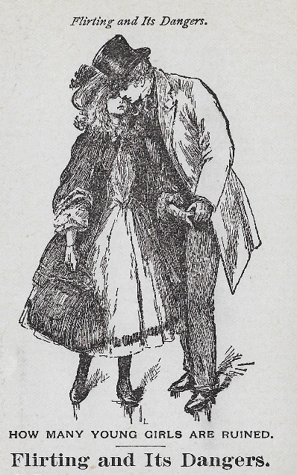
To quote Jefferis, “Let the reader of this work study its pages carefully and be able to give safe counsel and advice to others, and remember that purity of purpose and purity of character are the brightest jewels in the crown of immortality.”

Upcoming Activities at The Dudley Farm
Our Big Barn Project is completed; Ice house with restrooms is all set; the Milk house is done. What a year! So come visit us “down on the Farm” to help us celebrate! September: On September 7th The Farmers’ Market hosted a Fairy and Elf Festival for the younger folks - and young at heart – to enjoy. And of course, we hope to see you at the Guilford Fair September 20th – 22nd.
October: Plans are being made for a grand celebration at this year’s Harvest Day to be held October 19th (rain date October 26th). Those who have attended in the past know that there are great activities for young and old, food to be had, and lots of entertainment. While there is no charge for admission, we do ask for a donation to the Guilford Food Bank to help celebrate our bounty. December: We will again invite all to come to our Holiday Open House and Market, December 7th, 8th and 14th. This will be your last opportunity to buy raffle tickets for the quilt, with the winning ticket selected on the 14th. More details will be available on our website and Facebook pages, as well as through Dudley Farm Doings.

The Dudley Farm Farmers’ Market
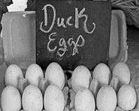
Martha Haeseler, Market Master
Photo by Barbara Hanson

I am pleased to report that the Farmers’ Market has been thriving this summer, with several new vendors and special activities. We have had good weather and strong customer support, and many happy reunions between dog friends who met in the Market. Here are some musings:
The Dudley Farm Farmers’ Market, with its cast of vendors, tents, displays and all manner of goods, seems to spring up overnight like mushrooms after the rain, and soon disappears again. But consider what goes on behind the scenes:
All week long vendors are crafting artworks and natural body products, baking, and growing and harvesting veggies, animals and eggs. For some, there may be a lot of last-minute details, such as wrapping and labeling new products. Others wait until it is light enough Saturday mornings to rush out and pick and wash the herbs and vegetables they offer. Some have to milk the goats and tend to the animals and poultry before they come. Bakers are working in the wee hours. Then everyone must pack their cars with their heavy tents, tables, displays, crates full of heavy pottery, freezers full of meat, vases of flowers, and all the other products vendors offer. Some travel a distance, some live nearby, and most take at least an hour to set up their spaces.
Some vendors get up at dawn on Saturdays after working a full week at another job. Others, such as fireman, EMT, and blacksmith Al Kostuk, might come to the market with his heavy kettle corn drum after fighting fires and saving lives all night. There are many backstories of vendors' complicated lives, yet they are all there, even on the hottest summer Saturday mornings, with their creations and a smile.
Why do we do this? It is not only our livelihood, our vocation. Perhaps we take great pleasure in making and growing things, and delight in seeing our creations walk away in the hands of people who will enjoy them. Perhaps we want to make a difference in the world and in peoples’ lives, by offering products that bring health and beauty. Perhaps we enjoy spending time on a beautiful farm in each other’s’ company. Perhaps we enjoy our interactions with you, our customers, welcoming you into our worlds and learning about yours.
You, our customers, have many backstories about what goes on in your lives and what it takes to get to the market on Saturday mornings, and yet there you are, supporting and encouraging our farmers, bakers, and artisans. Thank you for being a friend to our Market.
As I write this, we are in the Dog Days of Summer. We have celebrated National Farmers’ Market Week with Farm Day in August, and look forward to the Fairy and Elf Festival in
September and Harvest Day in October. We will be ending the year with our Holiday Market and Open House, which this year will be held on December 7, 8, and 14.

Garden News
Judy Stone, Garden Committee Coordinator

I am writing this on one of the hottest days of the summer, too hot to tackle the weeds in all of the gardens, especially my own plot at the Community Garden. The tomatoes and peppers are loving it, and the corn and squash in the Heritage Garden are growing almost visibly. The Community Gardeners are enjoying cookouts organized by several of the members of the garden. This year we are so fortunate to have several new volunteers and more in the offing. But we can always use more help, both with the work of weeding and maintaining the gardens and with new and creative ideas. Right now we are planning some fun additions to the children's space in the Three Sister's Garden, and by the time the newsletter comes to press, they may be in place. During the fall we will have a harvest of the colorful corn and beans and squash. Come and see! Still on my wishlist is a volunteer to take charge of the small flower border in front of the house. It is a very manageable job, and knowledge of historic plantings would be a plus. The border by the fence near the road also needs attention. If you are interested, I can be contacted at gardens@dudleyfarm or by leaving a message at 203-457-0770. A big thank you to volunteers Bill Green, Jim Scott, Susanne Durno, Wendy Brown, Ray Guimont, Ray Wenzel, Deb Bonner, Gabriella Radujko, David Cundy, Luis Maldonado and many others over the years. As well as the Guilford Garden Club for their generous support of the Heritage Garden. Come and join the fun! While we have adequate volunteers for the Heritage Garden, the Herb Garden and small flower border in front of the farmhouse are in need of renovation and more volunteers. I am proposing a co-chair of the Garden Committee to take responsibility for planning and maintaining those gardens. They are not large in size but need some specific gardening skills and knowledge and ability to engage volunteers. It is a lovely spot and a fragrant job with the benefit of being able to harvest herbs. If you are interested in volunteering or becoming a committee co-chair, or know someone who is, please contact me at gardens@dudleyfarm.com or by calling the farm at 203-457-0770. Happy gardening, at The Dudley Farm or wherever you are!

“For Wee Folk”: “Small Things” for 19th Century Children at The Dudley Farm Museum
Jana Pietrzyk, Intern

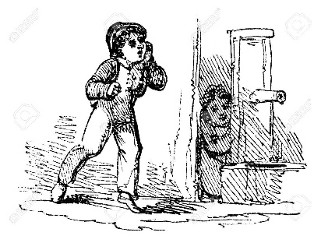
Before the age of super-sized toy stores, pampered children and helicopter parents, a child’s formative years were blurred somewhere between the stages of infancy and adulthood. It wasn’t until the 19th century that New England parents started to change their view on children completely; no longer were they seen as infants or small adults with no developmental stage in between. Now there was a middle ground where there became a market for toys, games and specialized clothing and furniture just to carve out a space for childhood.
The Dudley Farm Museum is highlighting artifacts like toys, games, children’s books clothing, and furniture, from 1870-1910 as our participation in For Wee Folk: Toys and Miniatures for Children exhibit. This summer-long exhibit is supplemented by four other Guilford historical museums, that will also be displaying children's items from their respective periods. Each exhibit intends to show how the view of children changed from a wide time-frame of 1639- 1910. At The Dudley Farm Museum, visitors will find additions to the usual collection peppered throughout the Dudley House, all that fit this summer's theme are marked with small signs that speak to the object on display.
The 19th Century brought out an increased awareness that "childhood" was an important time, separate from infancy, yet distinctly different from young adulthood and maturity. There was a new acceptance that there was instinctually a stage of growth where children were considered to be innocent as well as physically and mentally incapable of handling adult issues. Now children were seen as playful and cute and it was no longer acceptable to use physical punishment or soothing syrups such as opium to manage a child. However, constant supervision by an adult was not always possible. As a result, furniture designs shifted to fit the need of the parent. High chairs, cribs, and other "containment" furniture were developed and became popular in the 19th century because it kept the child safe and out of danger when the mother’s back was turned.
Baby carriages, once a mode of ‘airing' for the child became a popular way for mothers to walk the streets with their child in their Victorian-styled dresses, displaying their class and prestige.
Running a rural 19th-century household was a lot of work, and children were expected to do their share. Young girls and boys helped around the house – cleaning, doing kitchen chores, and tending the household garden. Tasks typically handled by children in early New England included: gathering eggs and firewood, hauling water, weeding the garden, gathering berries, picking apples, mucking out stalls, and emptying chamber pots.
Girls and boys were taught to sew and knit, which was a good way for children, as it helped to develop their fine motor skills. In the kitchen, children helped out by churning butter, pounding sugar, sifting flour, and stoning raisins (removing the seeds).
Boys as young as 9 or 10 were taught to “drive” a team of oxen, directing them to pull, haul, and plow on the farm by using a series of hand signals and voice commands, while young girls would learn how to iron when they were 7. Children would also pluck chickens and feed the pigs and other farm animals.
Many of today’s childrearing trends trace their origins to the early 19th century. Advice books dealing with the subject of raising children were numerous and often offered conflicting parenting strategies. Some advocated a strict approach to discipline, quashing an infant’s independent tendencies from an early age; other advice books tended toward the opposite extreme and favored leniency and freedom for children. Still others took a moderate approach somewhere between the two extremes. The 21st-century preoccupation with parenting techniques and raising children “properly” is not a new phenomenon!
But it was not all work and no play for children living on the farm. While most rural New England children had far fewer toys than a modern child, many of these toys would have been homemade – carved animals, board games scratched into a scrap of wood, roughly carved toy houses, and “rag baby” dolls made from bits of left-over fabric.
Social games and amusements were also popular among 19th-century children. Board games, once imported from England and Europe, were now beginning to be published in the United States. Some companies, like Milton Bradley in nearby Springfield, Massachusetts, are still in operation today. The Dudley Farm Museum is lucky to have a good number of these early amusements.
Like modern children, those of the 19th-century played with dolls and animals, were expected to help with household work, went to school, and looked forward to the time when they would be considered "grown-up."
To view this exhibit and others, come see us “Down on the Farm”.
household work, went to school, and looked forward to the time when they would be considered "grown-up."
To view this exhibit and others, come see us “Down on the Farm”.
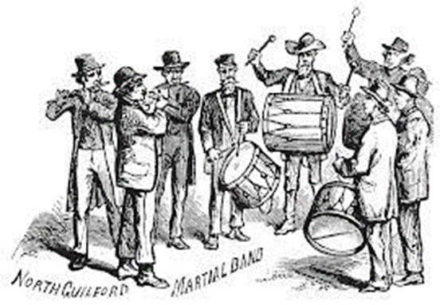

Hi, Ho! Come to the Fair!
Beth Payne

Guilford’s first fair, held in 1859, featured 426 oxen from Guilford, Madison, and North Branford. But the fair was canceled in 1862 as so many of Guilford’s young men were off to battle in the Civil War. The Fair resumed in 1863.
The Twelfth Annual Exhibition of the Guilford Agricultural Society was a grand affair memorialized in Frank Leslie’s Illustrated Newspaper (New York) on October 30, 1875. Note that the one-day fair was held on the green in October, and on Wednesday to not disturb the church-going population and allow all to return home before the Sabbath.

ANNUAL FAIR AT GUILFORD, CONN.
The good people of the quiet, old-fashioned town of Guilford, Conn., held their twelfth annual town fair on Wednesday, October 13th. It was a thoroughly hearty old-time gathering, characteristic of the loyalty and presenting pleasant features of homely, honest New England life. Guilford is a pleasant, antique-looking town. Many of the houses date back to the old colonial days. The old stone house occupied by the Rev. Henry Whitfield, an English nonconformist leader who settled here in 1639, is still standing. There are, however, a few fine buildings of modern date, and there is an air of quiet comfort and solid thrift about the place.
In the centre of the town is a beautiful public square or village green, on which front the hotel, the principal stores and several churches. This spot was the center of the fair, Beneath the fine old trees, whose leaves were touched with Autumn hues, in the streets, on the doorsteps, and in the neat little Music Hall, were arranged the articles on exhibition. Madison, Branford, Stony Creek and other adjacent towns vied with each other in displays of cattle and farm products. Teams of oxen with gayly decked horns, drawing wagons loaded with golden pumpkins, large squashes, crimson leeks, purple eggplants, bright apples, luscious pears, and every variety of fruit and vegetable, were gathered together on the green. Cages containing buff Cochins and golden-tipped Ducklings, pompous turkeys and Emden geese, were ranged along the fences and doorsteps. One farmer had a cage of young foxes, who looked with longing eyes upon the caged poultry. The usual display of peddlers, side-shows, wheel-of-fortune men and other inevitable accessories of a fair-ground, enlivened the outside scene. In the miniature hall were arranged the products of the day, canned fruit, pickles, specimens of cooking, and useful and fancy articles of domestic manufacture, the work of the hands of the fair daughters of Connecticut. Guilford was given up to fair, and everybody who came into the village could see all there was to be seen without money and without price. One of the features of the cavalcade was a venerable gentleman named Major Page. He is eighty-six years old, and the horse he rode was apparently coeval (or contemporary) with the Major. This veteran Militiaman, who lives in North Branford, commanded the Tenth Connecticut Militia fifty years ago. Not withstanding the burden of years, the Major is lively and sprightly. The Rev. W. H. H. Murray, the hunter of the Adirondacks, is one of the celebrities of Guilford, and took a prominent part in the fair. He has one of the finest stock farms in America, about three miles from the village, and takes great interest in the improvement of stock. He had offered seventy-five dollars in prizes for the best yearling colts from one of his celebrated horses. Live Oak, and a dozen or more of that animal’s progeny, were awarded to the entire satisfaction of their recipients. (See Winter/Spring 2019 Farm News for more about this man.) There was no race-track, other than the high-way, at this primitive fair, but the visitors were treated to a little display of horsemanship. The Rev. Mr. Murray handled the ribbons, and sped his two noted stallions, Live Oak and Abdallah, twice or thrice around the square.

(Illustration reprinted from Sketches by Albert Berghaus, an important illustrator of the time)
(According to the Shoreline Times of Apr. 23, 1908, the “Old New England Band” in the early 1880’s consisted of 18 members: Edmund Jillson, Virgil Hotchkiss; Sylvester Snow; William Fowler; George S. Benton; John Hotchkiss; Frank Hill; Chester M. Lee; Henry Chittenden; “Mikey” O’Brien; Joe Perry; Augustus Hall; Edward Bartlett; J. Douglas Loper; Robert Foote; Hiram Hall, and Frank Stearns. Henry E. Fowler was the leader. Others who participated in 1875 include David Benton, William Chittenden Charlie Beers on fifes, C.B. and Burton Byington, E. A. Leete, and Arthur Hall on tenor drum, and William Hall on bass drum. If you know anything about this organization, please let us know!)

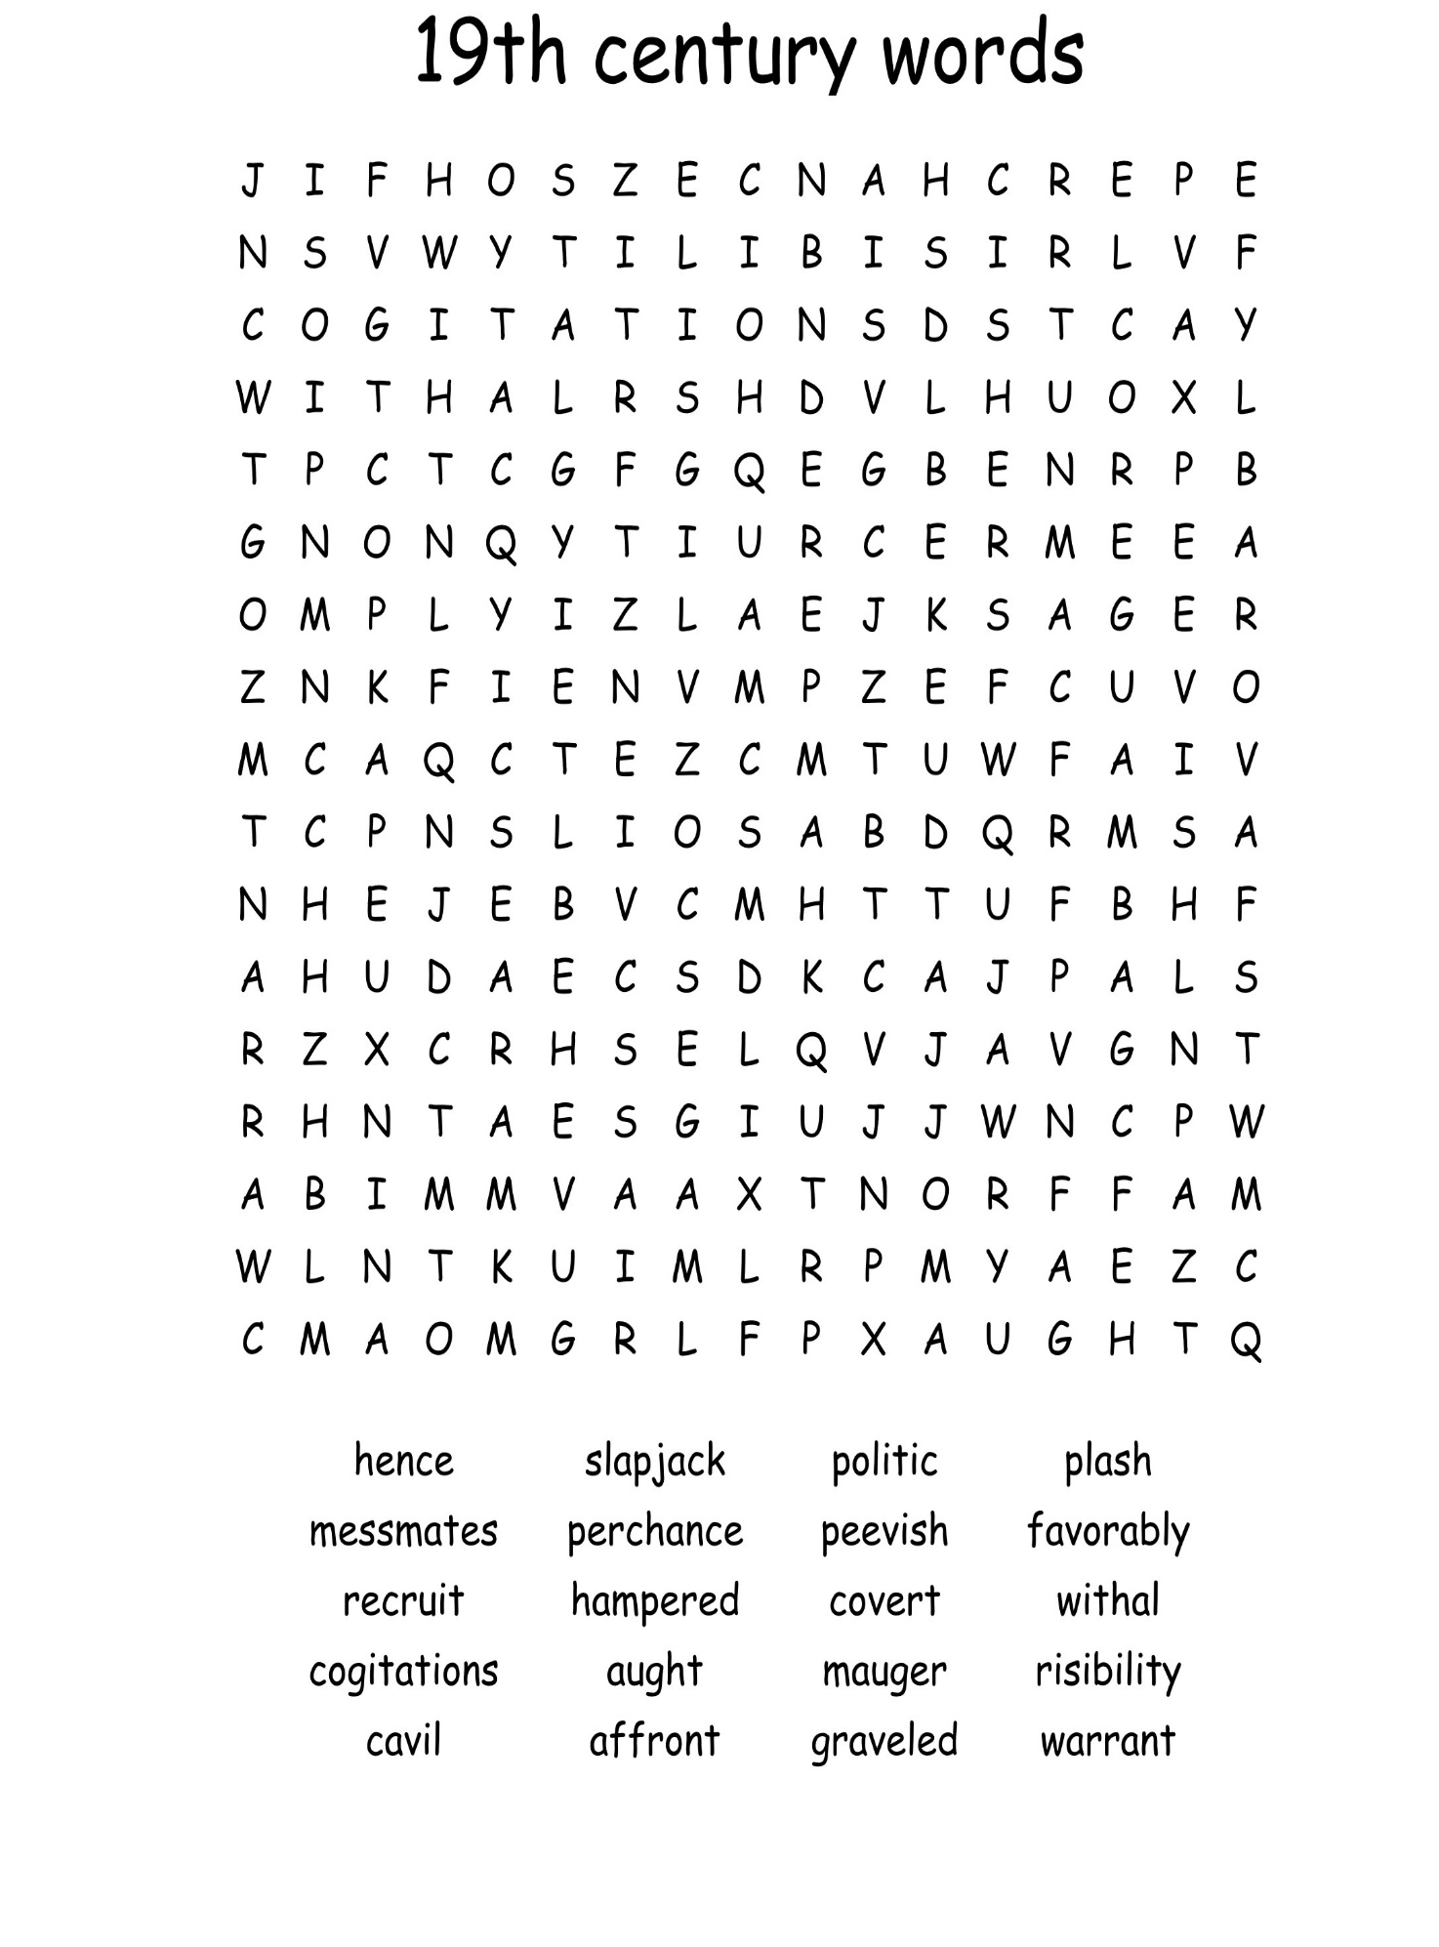

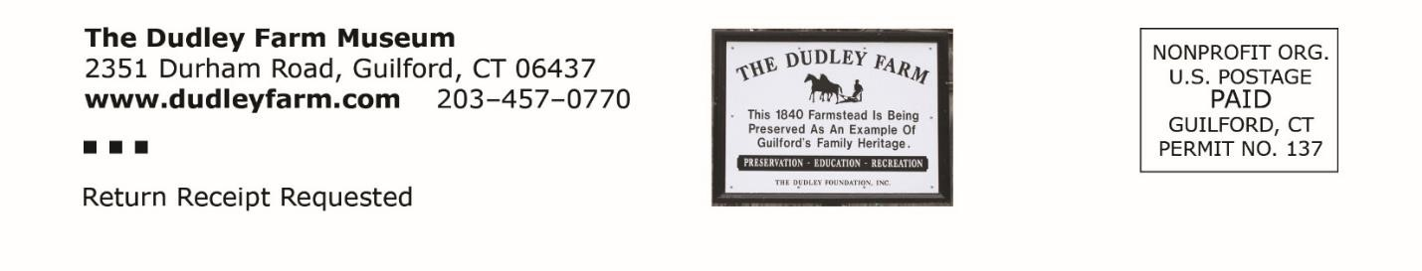
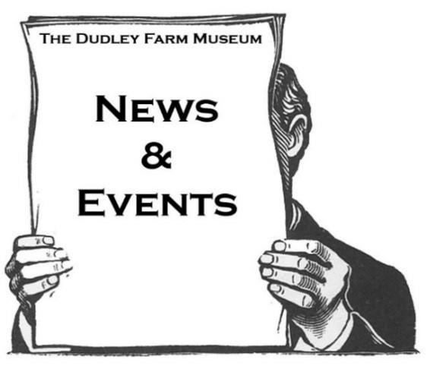 | The Dudley Farm Farmers’ Market  Saturday Morning, 6:30 PMs  9 AM to 12:30 PM through October  Dudley Farm Farmers’ Market Fairy and Elf Festival September 7  The Guilford Fair September 20-22  Annual Meeting and Pot-Luck Dinner Thursday October 17, 6:30 PM  Harvest Day at The Farm October 19, Rain Date October 26  Holiday Open House December 7, 8, and 14  For more information: www.dudleyfarm.com Ph. 203-457-0770 or email: Info@dudleyfarm.com

