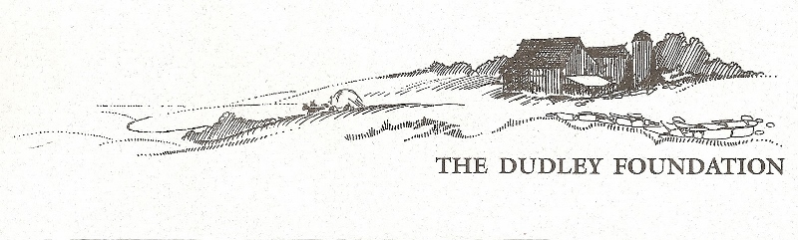
Annual Report 2022

From the Museum Director
Mission Statement
To preserve, restore and operate The Dudley Farm Museum as a late 19th century historical, educational and recreational resource to serve the general public.
2022 has proven to be a very busy year for our organization. Our website (www.dudleyfarm.com) has been revised and sees much activity, well-maintained by Board member Ray Guimont, while our Facebook page keeps the public current with almost 1700 “likes” from those who wish to follow all our happenings. (www.facebook.com/dudleyfarmmuseum). Dudley Farm Doings, an electronic mailing, is sent out at least monthly, now reaching more than 700 subscribers. Despite the continued challenges of the pandemic we have assured that subscribers are able to keep in touch with The Dudley Farm and can read a bit about 19th-century farm life. Topics have remained varied and have included such things as mud month, maple sugaring, droughts in New England and wine berries! These word pictures about life on the farm have been very well received and are emailed to people all around the country. Our Farmers’ Market continues to attract new folks to the Farm. Under the capable leadership of our Market Managers, Steve Rowe and Katrina Bonvini, the Market has not only seen a lot of favorable press (and has its own Facebook page and Instagram account), but has had a steadily growing client base. We are sorry that Katrina is no longer here, but she will continue to be involved through 2022; we wish her and daughter Carmen all the best as they start new adventures living in Maine. Now she’s a down’easter! She will be missed… The Munger Barn remains a popular wedding and event venue providing needed financial support for maintaining our numerous buildings. Support for the Museum’s operations has been received thanks to grants from Connecticut Humanities and many generous individuals, some of whom gave through The GreatGive. The Board made the difficult decision this past spring to take advantage of the real estate market and sell the Barrows Farm, allowing us to establish a much-needed endowment fund.
Judy Stone continues to marshal her gardeners, keeping the Community Garden busy, while also getting help from the Guilford Garden Club to maintain our Heritage Garden. This year sunflowers were planted to honor Ukraine. Thanks to Jim Powers and his committee – Maria Trumpler, Don Homer, and Doug Williamson - plans for the construction of a new building to house the Quinnipiac Dawnland Museum and showcase the story of the Quinnipiacs who inhabited this area, is progressing well. We continue to search for folk who may have Quinnipiac ancestry and would love to hear from them. By the time you read this, our Chase Turbine sawmill may be in place! Check it out near the Community Garden. Wow! Thanks to your support we continue assure our vision will become a reality. Vision Statement
The Dudley Foundation will provide leadership to the greater community in the promotion of historic awareness and interpretation of the history of the North Guilford Community. We managed to do more than just keep solvent in 2022 and we continue to build on that success. If you have not been involved, I ask that you consider volunteering, and/or financially contributing to our organization’s many projects. Thank you so much. Beth Payne, Museum Director
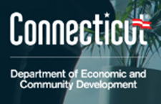
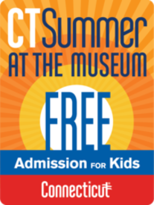
What did we do in 2022? We again saw activity “down on the Farm” before our doors were even opened for the season, with Dudley Farm Maple Syrup produced in our sugar house thanks to Bill Black, Jim Powers, Tom Leddy, Becky Gladych and Mary Hotchkiss and her faithful dog Bee under the watchful guidance of Buster Scranton. People were eager to do get out of their homes and enjoy some time at the Farm. Our Rug Hooking workshop, a sold-out 3-day event, made a return in March thanks to Michele Micarelli (www.michelemicarelli.com). Teri Stratton led a popular 2-day rug braiding workshop. We hope to repeat this in the spring. We again had a CCSU Public History intern who helped us develop our granary exhibit. Along with high schooler Henry Young, Joseph Mumley worked hard to do the research and search out the artifacts to make this exhibit happen. Speaking of help – we remain in need of a regular handyman! Any ideas? Let us know. The State of Connecticut repeated last year’s program entitled “Connecticut Summer at the Museum - Free Admission for Kids”. Families from around the state took advantage of this popular program. The Dudley Foundation’s successful tag sale in May was repeated in October. This event remains very popular. Thankfully…we have docents! Four talented women from the area now help to lead tours not only in the Farmhouse, but also at the Quinnipiac Dawnland Museum. We were busy enough this summer to really use their help. AND we have successfully been nominated for inclusion in the National Register of Historic Places! This is the official list of our country's historic buildings, districts, sites, structures, and objects worthy of preservation and required exhaustive research into The Dudley Farm history
And we received grants:
CT Cultural Grant The Dudley Foundation received a $9,300 CT Cultural Fund Operating Support Grant from Connecticut Humanities, with funding provided by the Connecticut State Department of Economic and Community Development/Connecticut Office of the Arts (COA) from the Connecticut State Legislature. This funding was provided to address the needs of museums as they recover from the impact of COVID-19. We used a large portion of these funds for the much-needed updating of the Dudley Farm Museum’s website to attract potential visitors and make finding information easier.
SHARP Grant The Dudley Foundation was awarded a $10,000 Connecticut Humanities SHARP Capacity Grant to support exhibit planning for the Quinnipiac Dawnland Collection. Connecticut Humanities is the statewide, nonprofit affiliate of the National Endowment for the Humanities (NEH). Jim Powers, board member and respected historian on indigenous people of the CT Shoreline, along with committee members have been working with 2 exhibit designers with the goal of completing the design work and installation by mid-2023. Museum Make-over The Dudley Farm Museum was selected by the Connecticut League of History Organizations as one of 15 local history organizations to be awarded up to $3,000 as well as free visits from museum consultants to develop a plan to improve certain areas of the museum and the visitor experience through a new program, “Museum Makeover”. This grant was made by Conservation ConneCTion, in partnership with the Connecticut League of History Organizations and Connecticut Humanities. The area selected with the traveling museum curators was The Granary in the Big Barn. Please see what we’ve done.
And a special thanks to Our Board of Directors
This past year was a particularly busy one for our Board, and they proved their mettle with the many challenges: grants, website update, fencing needs, supply chain issues, National Registry nomination, and more. They deserve all our thanks and appreciation.
So Won’t You Consider ---
-Giving an additional gift to our organization. As you know, there is no governmental funding, and financial contributions are needed for day-to-day operations as well as special projects, including replacing the sills under the house, creating a structure to house our sawmill, reconstructing our Aermotor windmill, and providing a building to better serve the Quinnipiac Dawnland Museum. -Volunteering to assist in one of our many projects or as a committee member. There is much work to be done. So far over 50 volunteers have contributed more than 2500 hours of time to the Foundation in 2021– valued at more than $80,000!-Join our Board – bring your fresh ideas to help us grow.

