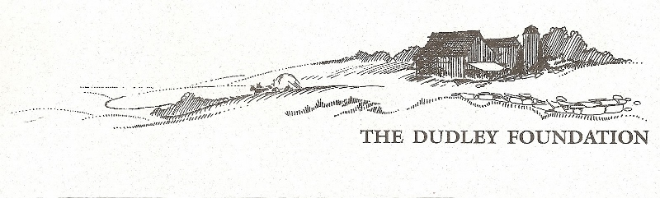Annual Report 2023

**From the Museum Director**

**Mission Statement**  
To preserve, restore and operate The Dudley Farm Museum as a late 19th century historical, educational and recreational resource to serve the general public.

****2023*** remains busy for our organization. Our website ([www.dudleyfarm.com](http://www.dudleyfarm.com)) sees much activity, well-maintained by Board member Ray Guimont, while our Facebook page keeps the public current with over 2000 followers ([www.facebook.com/dudleyfarmmuseum](http://www.facebook.com/dudleyfarmmuseum)). ***D***udley Farm Doings, our electronic mailing, is sent out at least monthly, now reaching more than 800 subscribers, assuring that they can keep in touch with The Dudley Farm and while reading a bit about 19th-century farm life. These word pictures about life on the farm have been very well received and are emailed to people all around the country. ***O****ur* Farmers’ Market attracts new folks to the Farm. Under the capable leadership of our Market Manager, Steve Rowe, the Market has seen a lot of favorable press (with its own Facebook page and Instagram account) and continues to have a steadily growing client base. We are sorry that Steve will no longer be managing the Market in 2024, but we’re pretty sure he will still show up now and then. ***T***he Munger Barn is once again a popular wedding and event venue providing needed financial support for maintaining our numerous buildings. Support for the Museum’s operations has been received thanks to grants from Connecticut Humanities and the Community Foundation for Greater New Haven, the Summer Hill Foundation and many generous individuals. ***J***udy Stone encourages her gardeners, keeping the Community Garden busy, while getting help from the Guilford Garden Club to maintain our Heritage Garden. ***T***hanks to Jim Powers and his committee – Maria Trumpler, Don Homer, and Doug Williamson – as well as grants from Connecticut Humanities and the Summer Hill Foundation the Quinnipiac Dawnland Museum was not only completed, but opened to the public in September! This new exhibit showcases the story of the Quinnipiac people who inhabited this area. We hope this project will help us find and acknowledge folk who may have Quinnipiac ancestry. We would love to hear from them. ***O***ur Chase Turbine sawmill shows slow progress, and real plans are being made for our Aermotor Windmill. The Granary exhibit has been well received, and thanks to the generosity of Keith Bishop, our Milkhouse is also complete. Plans are being made and slowly implemented for the Farm Workshop section of the Big Barn. And of course, we are still raising money to purchase Miss Molly, the Marvelous Milking Cow. Wow! Thanks to your support to assure our vision is becoming a reality. **Vision Statement**  
The Dudley Foundation will provide leadership to the greater community in the promotion of historic awareness and interpretation of the history of the North Guilford Community. ***W***e managed to do more than just keep solvent in 2023 and we continue to build on that success. If you have not been involved, I ask that you consider volunteering, and/or financially contributing to our organization’s many projects. Thank you so much. *Beth Payne*, Museum Director

**What did we do in 2023?**

We saw activity “down on the Farm” before our doors were opened for the season, with Dudley Farm Maple Syrup produced in our sugar house thanks to Bill Black, Jim Powers, Tom Leddy, Becky Gladych, Don Homer, Jerri Guadagno, Maria Trumpler and Mary Hotchkiss under the watchful guidance of Buster Scranton. People were eager to do get out of their homes and enjoy some time at the Farm. An early spring wildflower walk in the woods was enjoyed by several who tolerated the light drizzle of the day. High schooler Henry Young returned for the summer, helping to clean the many tools we have under the direction of John Otte and Steve vanDerMaelen as we prepare our Farm Workshop exhibit. 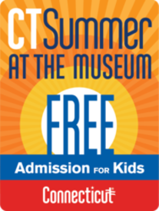 The State of Connecticut repeated last year’s program entitled “Connecticut Summer at the Museum - Free Admission for Kids”. Families from around the state took advantage of this popular program. The Dudley Foundation’s successful and popular tag sale in May was repeated in August. Thankfully…we have docents! Four talented women from the area help to lead tours not only in the Farmhouse, but also at the Quinnipiac Dawnland Museum.

The Dudley Foundation is very proud to now be listed on the National Register of Historic Places! Together with the Meeting House Hill Historic District, North Guilford’s Dudleyville is very well represented on this prestigious list, the official list of our country's historic buildings, districts, sites, structures, and objects worthy of preservation**.**

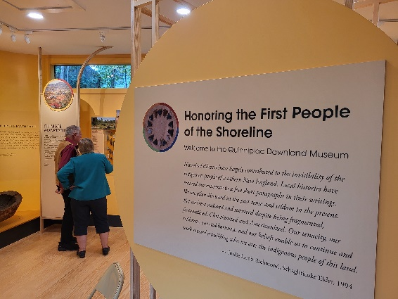Jim Powers has been very busy speaking around the state about the history of the Quinnipiac people and assuring that the word gets out about our new Quinnipiac Dawnland Museum at The Dudley Farm.

As Museum Director I attended and presented at two national conferences. In June I co-presented with Kandie Carle at the annual Association for Living History, Farm and Agricultural Museums in in Ohio. Our presentation was about fabrics from 1837-1937 as represented in a fabric scrapbook kept by Amy Dudley’s mother-in-law. In September I was a co-presenter with others from the Connecticut League of History Organizations at the annual Association for State and Local History conference in Boise, Idaho. This time The Dudley Farm Granary was featured as part of the MuseumMakeover project.

**And we received grants:**

****Summer Hill Foundation, Keith Bishop,

Logo

**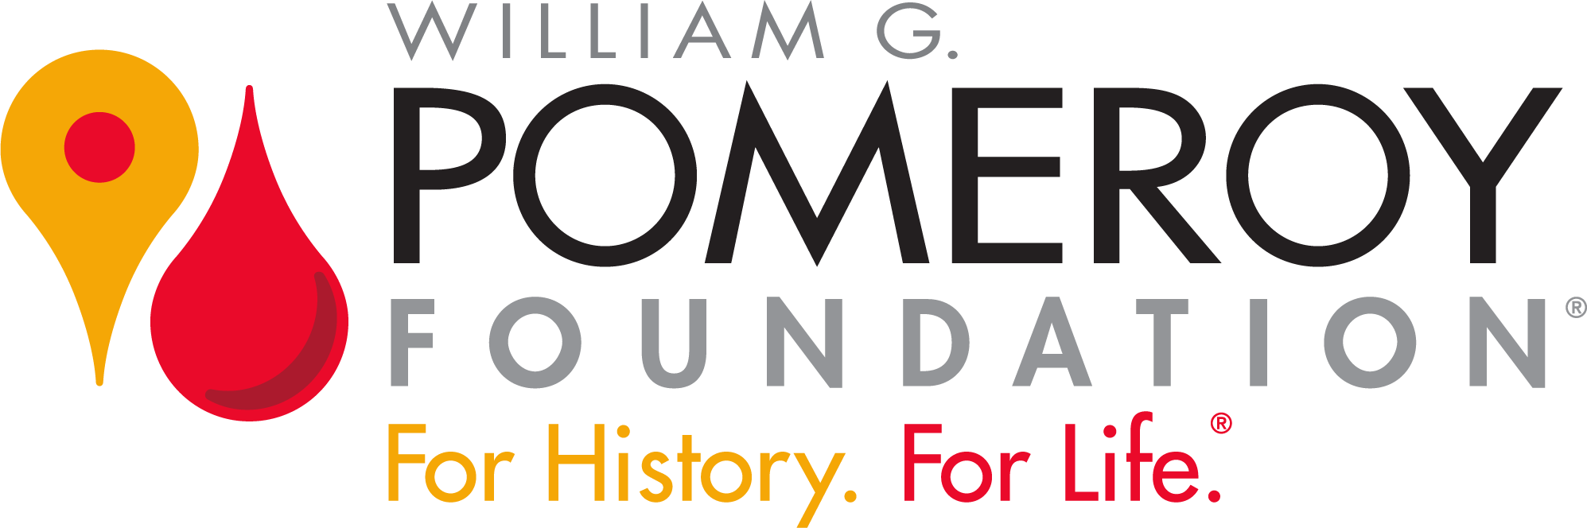 *A special thanks to Our Board of Directors***

This past year was a particularly busy one for our Board, and they proved their mettle with the many challenges: grants, supply chain issues, National Registry nomination, and more. They deserve all our thanks and appreciation.

***So Won’t You Consider ---***

-Giving an additional gift to our organization. As you know, there is no governmental funding, and financial contributions are needed for day-to-day operations as well as special projects, including replacing the sills under the house, creating a structure to house our sawmill, reconstructing our Aermotor windmill, and special programs and exhibits. -Volunteering to assist in one of our many projects or as a committee member. Do you enjoy working with children? And learning about North Guilford’s history? We could use an individual to help develop and implement field trips for young and old! There is much work to be done. So far over 50 volunteers have contributed more than 2500 hours of time to the Foundation in 2021– valued at more than $80,000!-Join our Board – bring your fresh ideas to help us grow.