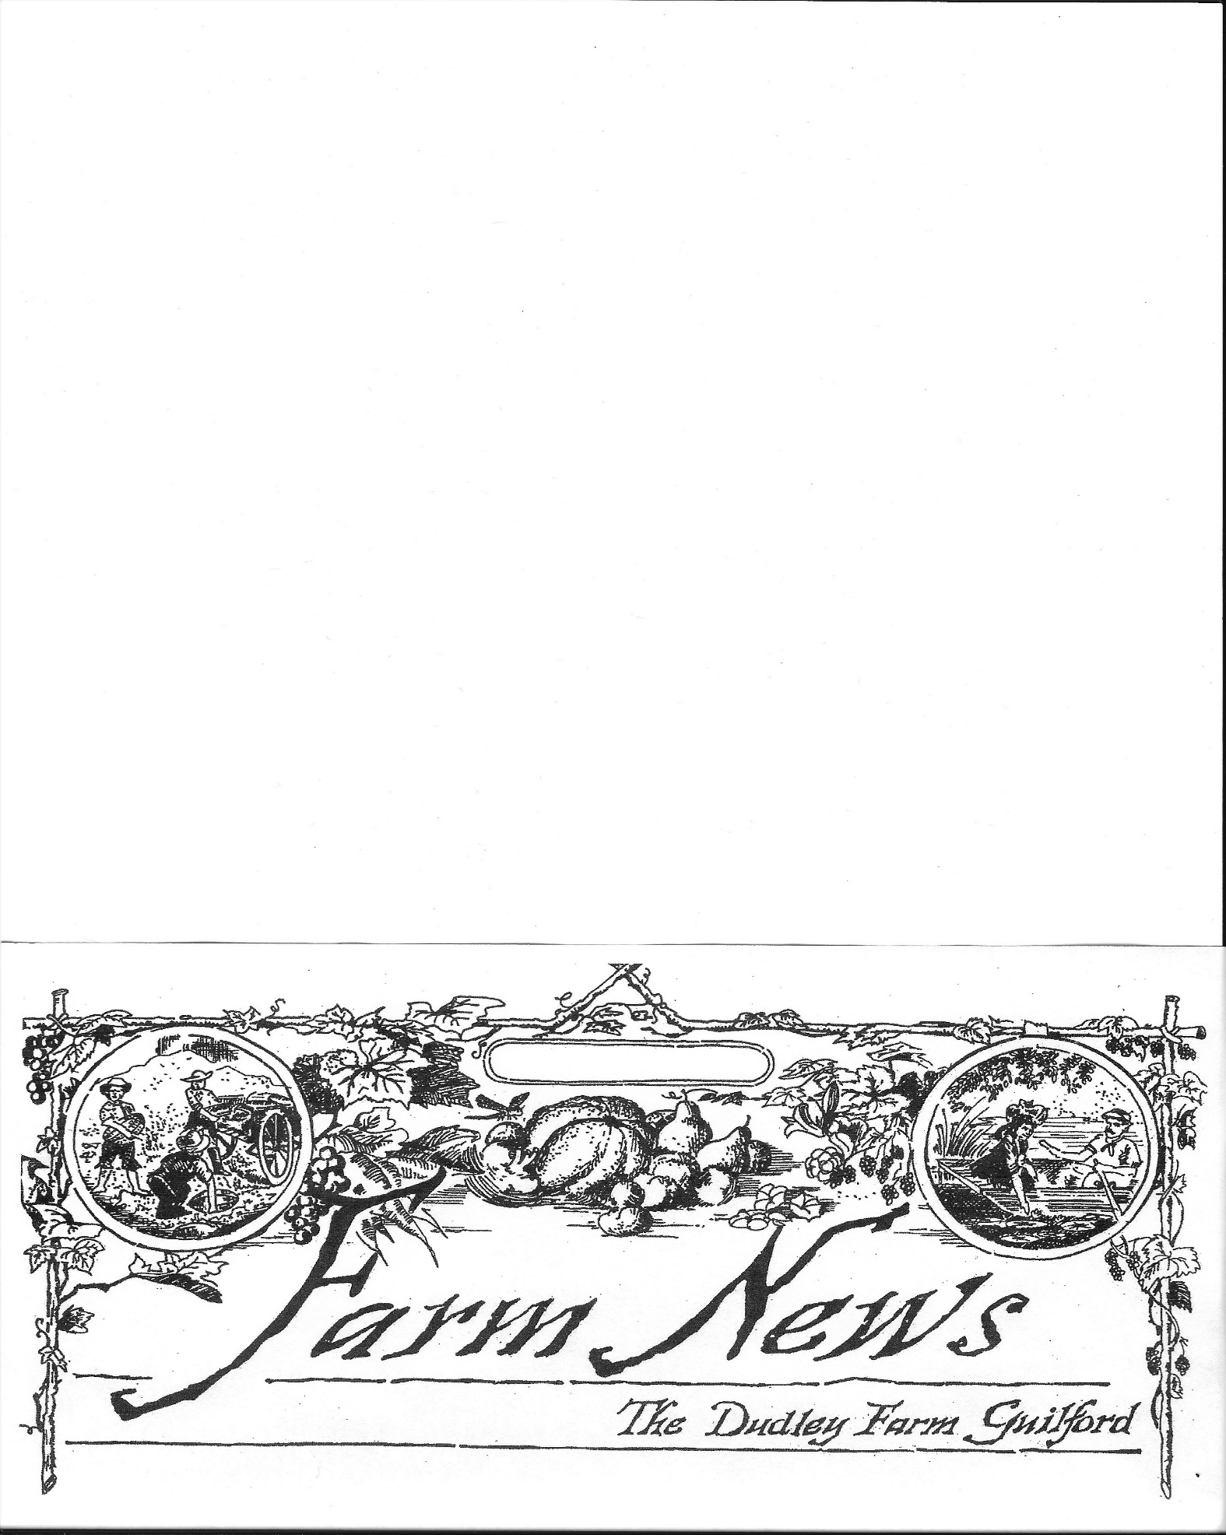

Autumn 2024

~2351 Durham Road, Guilford, CT ● 203.457.0770 ● [www.dudleyfarm.com~](http://www.dudleyfarm.com~/)

**Mission Statement**

*"To preserve, restore, and operate the farm as a historical, educational, and recreational resource for the public.’’*

## President’s Corner

A Message from Maria Trumpler

***H***ave you listened to our new audio tour? If not, you can access it via the QR code on the map in the kiosk and below or from the “Visit” page of the dudleyfarm.com website. Since our museums and barn exhibits are open only a few hours a week, we want to offer visitors round-the-clock historical reflections that can guide them around our 10 acres. We focus primarily on environmental history and how a small family farm gets water (from wells, the river, and collecting rainwater) and disposes of waste (recycling, repurposing, and burying). Opting not to specialize in particular crops or livestock, the Dudley Farm sold and bartered a little bit of everything: eggs, flowers, butter, charcoal, ice, leather, wool, and rye flour. When a tool broke or they needed a new one, they fashioned it themselves in their workshop and with blacksmithing. Animals like dairy cows, oxen, sheep, and chickens were constant companions.

We designed the farm tour so it can be listened to on your phone while walking around the property or in the comfort of your favorite chair. Just click on each stop and you’ll hear about 3 minutes of commentary. Hopefully, the material and musings we share will entice you to visit the farm in person and see things you may have missed previously, such as the new trail to the ice pond or the millstones.

In the “Bonus Conversation” section of the tour, Board Members Jim Powers, Sharon Bloom and I reflect on how the Museum has developed over the past 30 years and where we might go in the next 30 years. Jim reflects on the many people and organizations that have helped us restore the Dudley Farm. Sharon expresses hope that our visitors will feel a connection to the land and get a glimpse of what it was like to tend the land a century ago.

Your ongoing help is vital to realizing our vision for the next 30 years. This is membership renewal time and you will find an envelope inside this newsletter. The Board voted to reduce our membership categories and raise the rates for the first time in over a decade. Your membership dues fund the ten percent of our annual budget that we use for upkeep and operating expenses on our beautiful farm. It is

gratifying to know that you are

enthusiastic about what we are doing to create a multi-sensory

|  |
| --- |
| **Officers and Directors**  **President** – Maria Trumpler  **Vice-President** – James Powers  **Treasurer –** Bill Black  **Assistant Treasurer** – Susan Torre  **Recording Secretary –** Jerri Guadagno  **Corresponding Secretary –** Dottie Crampton  **Board Members -** Ray Guimont, Don Homer, Kendrick Norris, Tom Leddy, Sharon Bloom Doug Williamson, Buster Scranton, Mary Norris  **Museum Director –** Beth Payne  **Newsletter Staff –** Bill Black, Beth Payne  **Website** – www.dudleyfarm.com  **Facebook** - www.facebook.com/dudleyfarmmuseum  **Email-** Ngdudleyfarm@gmail.com  **Dudley Farm Office** – 203-457-0770  The Dudley Foundation is a 501 (c)(3) non-profit organization and contributions are tax-deductible. |

enthusiastic about what we are doing to create a multi-sensory experience of Guilford’s agricultural history. Please make sure that we have your email address so that you can be quickly informed of any important developments.



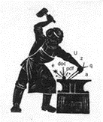

**The Nineteenth-Century Wordsmith**

Beth Payne

***Simon:*** *Did you hear about the corn farmer who won the Nobel Peace Prize?*

***April:*** *No, Simon, I did not hear about the corn farmer who won the Nobel Peace Prize.*

***Simon:*** *Yes. Apparently, he won it for his contribution to world hominy.*

***A***h, the 19th Century Wordsmith has eaten – and heard – her share of corn over the years. Corn-cracker, can of corn, corny—all are expressions many of us have not only heard but have used. To paraphrase *Eleanor Rigby*, where do they all come from?

Well, let’s start with a “can of corn.”

As baseball fans may know, a "can of corn" is a routine fly ball hit to an outfielder. What?? Why!

It all started at the 19th-century grocery store. When 19th-century clerks at grocery and general stores were looking for an easier way to reach canned goods on high shelves, they started using long, hooked sticks to pull them down …a long-handled grabber that I find indispensable today. The dropped cans would be caught in the clerk’s aprons -- just like a fly ball.

Who knew?? I guess we’ll just have to “acknowledge the corn” and agree to admit the truth of the matter. To the Oxford English Dictionary (OED) the word CORN means hardened skin and it assigns this American expression to a category of phrase which includes 'treading on one's corns' with the implication that one is acknowledging, albeit metaphorically, such a painful fact.

English etymology also claims that the expression arose in 1928 during a Congressional debate regarding the UK’s Corn Laws. The **Corn Laws** were tariffs and other trade restrictions on imported food and corn enforced in the United Kingdom between 1815 and 1846. The word *corn* in British English denoted all cereal grains, including wheat, oats, and barley. The laws were designed to keep corn (grain) prices high to favor domestic (UK) farmers. The Corn Laws blocked the import of cheap corn, initially by simply forbidding importation below a set price, and later by imposing steep import duties, making it too expensive to import it from abroad, even when food supplies were short. Claiming to export corn, one of the states (Indiana?) was forced to admit that the cereal in question was, in fact, used to feed hogs, and defended that position by declaring that the corn was still being exported in the form of hogs! I guess there is a kernel of truth there somewhere! Sounds like many a politician campaigning where there is a singular element of truth or wisdom within the greater speech, or claim, especially when most or all other elements are fictitious or of questionable veracity.

*I think the governor's speech is a bunch of hogwash by and large, but there is a kernel of truth in what he said about the need for lower taxes.*

*Is there a kernel of truth to this rumor of layoffs? Please say no.*

*There is not one kernel of truth in any of that nonsense you just said!*

19th-centuryinsults could be pretty colorful – and harsh. So it is with the term *corn-cracker*. Used with disparaging intent it is insulting, being similar in connotation to redneck and hillbilly. Originally corn-cracker referred to a native of Kentucky or Georgia, but has come to apply. to any poor white person in the South.

When something is trite or silly, people often refer to it as corny. Late 19th-century seed catalogs frequently added humorous stories and jokes in between the product listings. These anecdotes took the name of “corn jokes” and later were just simply called “corny.”

Corn offers a great example of how English words evolved in America. Before 1492, the plant that Americans call corn (Zea mays) was unknown in England. The word corn was a general term for grain, usually referring to whichever cereal crop was most abundant in the region. For instance, corn meant wheat in England, but was usually referred to oats in Ireland. When American corn came to Britain, it was named maize, the English version of mahiz, an Indigenous Arawakan word adopted by the Spanish. When the first colonists encountered it in North America, however, they almost always referred to it as corn or Indian corn, probably because it was the main cereal crop of the area. Both John Smith and William Bradford nearly always called it corn in their writings, only using maize occasionally. Smith mentioned corn frequently in his reports of his dealings with the Powhatans. In 1607, he wrote, “Our provision being now within twenty days spent, the Indians brought us great store both of corn and bread readymade.” He also used the same word to refer to the seeds brought from England: “Our next course was to turn husbandmen, to fell trees and set corn.” The seeds in question were probably wheat (or at any rate, not maize), suggesting that Smith still used corn as a general term for any staple cereal crop. Corn was central to survival for the English settlers, so corn terms soon proliferated. In Noah Webster’s 1828 dictionary, the entries under corn cover two columns. These include the terms corn basket, corn blade, corn cutter, corn flour, corn field, corn mill, and cornstalk, among others. Webster defined corn the way the English do, as a cover term for any grain, but noted, “In the United States…by custom, it is appropriated to maize.” Other corn-related words that came into the language early on are succotash, hominy, and pone, all from Algonquian languages. In his narratives, Smith referred to “the bread which they call ponap,” and also described “homini” as “bruised Indian corn pounded and boiled thick.” The terms roasting ear, johnnycake, and hoecake (both cakes made from cornmeal) were all in use by the eighteenth century.

Much of the landscape of North America was new to the English, so many early word inventions applied to the natural world. Often these simply combined a noun with an adjective: backcountry, backwoods (and backwoodsman), back settlement, pine barrens, canebrake, salt lick, foothill, underbrush, bottomland, cold snap. Plants and animals were similarly named, for instance, fox grape, live oak, bluegrass, timothy grass, bullfrog, catfish, copperhead, lightning bug, garter snake, and katydid (a grasshopper named for the sound it makes). All were part of the vocabulary by the mid-eighteenth century.

Well, that’s enough corniness for one day. Oh, just one more…

**Candy Corn Hits Shelves  (1898)**

***E***arlier this year the candy market was struck by the introduction of a new candy. Shaped like a corn kernel with three distinct stripes, candy corn or “chicken feed” is becoming a fast hit in the American candy industry.

This candy comes from the Goelitz Confectionery Company. Brothers Gustav and Albert Goelitz, who immigrated to Illinois from Germany, founded the company. This year ownership shifted to Gustav’s sons.

**Notice of Annual Meeting and Call for Nominations for the Board of Directors and Officers:**

***October 27th***

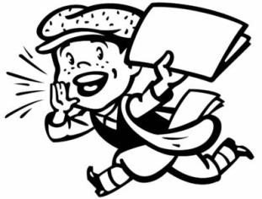

***T***he Dudley Foundation continues to grow and has come a long way since its beginnings 30 years ago in October 1994. Won’t you be a part of it by renewing your membership today?

The Annual Meeting of The Dudley Foundation and Pot-Luck dinner is scheduled for Sunday, October 27th, from 12 noon to 2 PM. *NOTE THIS IS A SUNDAY AFTERNOON!*

The Nominating Committee presents the following slate for the Officers and Board of Directors for next year.

**Officers:**(1-year term from October 2024 to October 2025)

President: Maria Trumpler

Vice President Jim Powers

Secretary Jerri Guadagno

Cor. Sec. Jane Limbach

Treasurer Bill Black

Ass’t Treas. Sue Torre

**Board of Directors** (Nominated for 3 year term from October 2024 to October 2027)

Ray Guimont

Donald Homer

Jim Powers

Mary Norris

Audrey Nefores

If you are interested or know someone interested in volunteering to help guide and run our operations, please contact our office at 203-457-0770 or email [director@dudleyfarm.com](mailto:director@dudleyfarm.com). Nominations will be accepted until October 15th.

Perhaps you are not interested in joining the Board, but would like to contribute in some other ongoing way (there are lots of jobs needing to be done!) - Let us know and we'll pass on your name to the appropriate Committee.

With your support, we can assure The Dudley Farm Museum will continue *"To preserve, restore, and operate the farm as a historical, educational, and recreational resource for the public.”*

***So Won’t You Consider ---***

-Giving an additional gift to our organization. As you know, there is no governmental funding, and financial contributions are needed for day-to-day operations as well as special projects, including replacingthe sills under the house and reconstructing our sawmill.

**From the Dudley Farm Recipe Box**

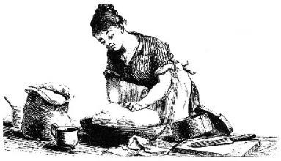Beth Payne

***A***nother Presidential election is just around the corner. Time for me to find my Election Day Cake recipe and bake it to take to the poll workers in North Guilford. They need some sort of reward for what they do!

Election Day was a cause for great celebration during the 18th and 19th centuries. Voters came to the major cities to cast their ballots and then stayed to socialize and celebrate. Often, city residents hosted elaborate banquets where the dessert course consisted of coffee, hot cider (maybe hard cider?), and a generous portion of Election Cake.

Although the cake began its association with the city of Hartford in the 1830s, Connecticut recipes for it date back to 1771. Back then, colonists might consume Election Cake during daylong town meetings or as a reward for their service after a long day of voting. In the early 19th century, as the parades and balls held in Hartford became more elaborate, Connecticut residents began identifying Election Day with the city of Hartford and the celebrations there became one of the great festivals in the state. As a result, Election Cake soon established itself as a Hartford tradition.

The popularity of Election Cake got a real boost from its publication in a reprint of Amelia Simmons’s recipe book, *American Cookery*, in 1800 (now known as Fannie Farmer). At a time when women faced little opportunity to display their political loyalty, (women’s suffrage was still years away) individuals like Amelia Simmons made food not only social but patriotic as well. Her recipe for Election Cake called for 30 quarts of flour, 10 pounds of butter, 14 pounds of sugar, 12 pounds of raisins, and 3 dozen eggs—an indication of the many mouths it was meant to feed. Then in 1857 Connecticut-born Catherine Beecher (Harriet Beecher Stowe’s sister), published a recipe for the *Hartford* Election Cake. And the baking was on!

Election Cake became the first food strongly associated with American politics. What made it more unique and important was the way it provided women with an opportunity to express their commitment to their new country despite not being able to vote.

There are numerous variations to the recipe. The one that follows is the one I prefer. But if you want to join in on this, there are lots of recipes online.

But don’t forget to vote!

***Hartford Election Day Cake***

**Ingredients**

* 1 cup whole milk heated to 110 degrees F
* 1 tablespoon dry yeast
* 1 cup mixed dried fruit such as raisins, dates, or cherries (all raisins would be fine)
* 3 tablespoons dark rum
* 1 tablespoon orange blossom water, or 1/2 teaspoon orange extract plus 1/2 teaspoon vanilla extract
* 3/4 cup brown sugar, packed
* 8 tablespoons butter softened, 1 stick
* 2 whole eggs
* 3 1/4 cup all-purpose flour
* 1/4 teaspoon salt
* 1/2 teaspoon allspice
* 1 teaspoon ground cinnamon
* 1/2 teaspoon coriander
* 1 cup walnuts, chopped
* Butter and flour to prepare bundt pan (or 2-3 loaf pans!)
* 3 tablespoons butter melted
* 3 tablespoons granulated sugar
* Mix the yeast with the heated milk and set aside.
* Mix the dried fruit with the rum and orange blossom water and set aside.
* In the bowl of a stand mixer with the paddle attachment, beat butter and brown sugar for two minutes on medium speed.
* Add eggs and beat for two more minutes.
* Drain liquid from dried fruit and add liquid to sugar and egg mixture. Mix to combine. Save the fruit for a later step.
* Sift flour into a bowl with the salt, allspice, cinnamon, and coriander.
* Transfer to a stand mixer from a paddle to a dough hook.
* Alternate adding flour-spice mixture and milk mixture to form a very sticky dough. Beat only long enough to bring the dough together. The mixture will be loose looking.
* Pour dough into a large bowl, cover with a dish towel, and let rise in a warm draft-free place for about two hours or until doubled in size.
* While the dough is rising, liberally butter and flour a 10” Bundt pan.
* Pour nuts and dried fruit into the dough and mix by hand just until mixed through.
* Scrape the mixture into the prepared pan.
* Cover with a dish towel and let rise until almost doubled in size, about an additional hour.
* Preheat oven to 350 degrees F.
* Bake in the center of the oven for about 40 minutes or until a toothpick inserted comes out clean.
* Remove from oven and brush with the melted butter then sprinkle on the granulated sugar. Serve warm out of the oven, or sliced and toasted with butter.

**Upcoming Events at The Dudley Farm**

***T***he Dudley Farm Museum plans many events of interest to our members. For updates, please check our Facebook page (<https://www.facebook.com/dudleyfarmmuseum>) and our website (<https://dudleyfarm.com/blog-news-events/>).

Available anytime is a self-guided tour of The Farm grounds. Links for our tours are on the website and in the kiosk at our parking lot. Take a walk around our Farm and learn about the sites and structures.

**September**means the Guilford Fair and Parade. We’ll be marching with the other museums in town, and be sure to check out our display at the fair.

*Maker's Monday at the Dudley Farm* continues every Monday afternoon in the Munger Barn. Are you crafty? Bring your work-in-progress project to craft in community as we quilt, knit, crochet, weave, stitch, etc., and see what your fellow crafters are up to. The group meets on Mondays, 1-3 PM. Can’t always make it? Fear not! Drop in as you are able. Questions? Call Mary Norris, at 203-415-0426.

*Foraging on the Farm*

Hmm. Should you eat that fungus growing in your yard? Before you take a chance, come learn how to start your wild plant and mushroom foraging journey safely and sustainably in our region. Led by Amy Demers, this two-hour-long class will cover wild plant and mushroom identification, toxic and deadly species to avoid, and how to prepare wild edibles.

The class includes a lecture portion where you will learn plant and mushroom identification, sustainability, and uses. Then we’ll go out on a walk on the Dudley Farm property and practice plant and mushroom ID out in the field.

This class is $25 per person, with 10% of ticket sales contributed to a donation to the Dudley Foundation. To sign up for the class, email [shroomsofct@gmail.com](mailto:shroomsofct@gmail.com) with the full name of all participants.

Amy Demers is a Doctor of Physical Therapy who started the Connecticut Foraging Club in 2021. The club offers monthly free foraging walks throughout CT, as well as foraging classes, where participants learn how to identify and utilize seasonal edible and medicinal plants and mushrooms.

Amy foraged for berries and field garlic as a child but has since learned how to forage for a variety of wild mushrooms, including maitake, chicken of the woods, oyster mushrooms, lion’s mane, chanterelles, honey mushrooms, wine caps, morels, Chaga, hemlock reishi, and turkey tails.

You can connect with Amy and learn more about CT Foraging Club on Instagram @ct_foraging_club or Facebook at Connecticut Foraging Club. You can join the CT Foraging Club email list by emailing [shroomsofct@gmail.com](mailto:shroomsofct@gmail.com) to receive information on upcoming foraging walks and classes.

Join us September 29, from 1-3 PM.

*Registration required; fee $25 (children under 12 free)*

**October**

What a busy month!

Are you a member of The Dudley Foundation? This year our annual meeting and potluck is being held on Sunday afternoon – October 27th beginning at noon.

We are pleased to welcome *Tom Kelleher, Historian, and Curator of Mechanical Arts at Old Sturbridge Village* in Sturbridge, Massachusetts, where he has worn many hats both literally and figuratively for over 40 years. A past president of the international Association for Living History, Farm and Agricultural Museums (ALHFAM), he regularly teaches and demonstrates at museums, parks, and historical societies across the country. His presentation looks at maple sugaring in early New England, when solid sugar, not pancake syrup, was a sweetener that some but far from all Yankee farm families produced. Tom examined farmers’ diaries, early newspaper accounts, as well as 19th-century agro-industrial censuses, reports, and other primary documents to determine not only how maple sugar was made, but who, why, and where it was made. He also proposes an answer to the question: why has maple syrup now supplanted maple sugar as a commodity?

Please join us for this sweet time!

***T***hen there is our annual Harvest Day, *October 19th*, a fun-filled family-friendly event for all. Win a giant pumpkin by guessing its weight, get your picture taken with our vintage Farmall tractor, have your face painted, or be a part of our American Gothic display.

Learn how 19th-century Guilford prepared for the coming cold weather. The New England Lace Group will return to show off their bobbin lace-making skills, and Maria Trumpler, our hard-working Foundation President, will be spinning wool on the Great Wheel. The blacksmith shop will be open, and our laundry center in operation. (Kids and water – always a winning combination!) And please visit Molly who would love to have you learn how to milk her!

Remember to look for the big red truck near the parking lot where you can drop off your donations for the Guilford Food Bank.

There will be demonstrations of 19th-century skills and crafts and lunch items will be available for purchase, but the event is free. Come spend a day Down on the Farm! Mark your calendar for *October 19th* from 10 AM to 2 PM. And don’t forget our Market!

**November** gives us all a chance to feast and celebrate with friends and families before we ring out 2024.

**December** finds us getting ready for the holidays with our Open House and Market during the first two weekends in December from 9 AM to 3 PM. Specialty items from our vendors will be sold in and around our Munger Barn, while on Sunday, *December 8th* from 1 PM to 4 PM, the Farmhouse will be decorated for the season and refreshments served. There will be cookies, music, and Santa to help get us into the spirit.

**Thanks ….**

***A***s Summer Ends…

We would like to thank our docents, Monique, Kate, Sharon, and Karen, for their continued enthusiastic interest and loyal participation in The Dudley Farm Museum this summer. We had some very busy days, and those days would have been far more difficult without them! Thank you so much.

**We Couldn’t Do It Without You!**

***W***e are fortunate to have businesses in the area donating their services to The Dudley Foundation. Family Tree in North Guilford has provided us with tree care and maintenance for years, including cutting down a very large maple tree that was dying from the inside out and threatening to fall. The Dirt Guy, located on the Guilford/Durham line, not only provided the soil and gravel needed to eliminate the deep and growing ruts in the driveway but ensured that the job next rainstorm didn’t lead to the ruts returning. Have you seen the structure built to house our sawmill? We have John Mills and Ryan Hough and family to thank for this beautiful hand-cut sawmill building

Thank you so very much!

**What Old Thing is New at The Dudley Farm Museum**

*Old Time Corn Husking Remembered*

***S***ometimes it’s not what old thing is new at the Dudley Farm, but finding out what that old thing hanging around the farm for over 100 years was for! And so it is with these two items used for husking corn.

Harvesting field corn (not the sweet corn that we eat all summer long) in the mid-west today is a lot different from how corn was harvested in the 19th century. Come November fields with a dozen or more combines will be busy going up and down the fields, picking, husking, and shelling the grain off the cob. Surely not a technique that the Dudleys would have known about.

Instead, corn was harvested after the haying was done. A corn binder may have been used to cut the stalks and bind them into shocks to stand in the field to dry. The ears could be stripped off by hand at that time or left in the shocks until corn was needed in the winter. After the ears were removed, the stalks could be used for animal feed and bedding – maybe even to freshen the mattresses in the house.

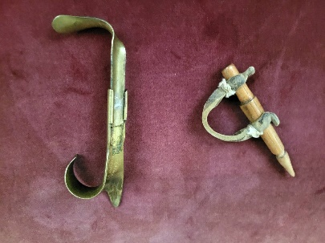But what a lot of work! That work was made easier with the use of a metal hook or wooden peg. And if you hosted a husking bee your friends and neighbors not only helped get the work done but would have a social event at the same time!

So how do you use these things? In use, the point of the husker is thrust through the husk-wrapped tip at the point of the ear. With the thumb pinching a section of the husk against the husker, a quick pull exposes the ear. The average farmer could husk 300 ears in 80 minutes!

And like so many other things where speed and skill count, there were contests. Take a look at this YouTube of such a contest in Nebraska. If you really get into it, check out the 1938 Newsreel of the National Championship!

<https://www.youtube.com/watch?v=N7tjANZpvQg> or the newsreel from the national contest in 1938!

<https://www.youtube.com/watch?v=-NMMijkum-0>

**Buster’s Musings**

* Corn*

***C***orn has been an important crop on farms like the Dudley Farm as feed for both their animals and for the animal owners. It can be a risky crop for many reasons- birds that pull the seedlings up; animals such as raccoons that go in and trash the crop just before it is ready; birds that peck the ears; hurricanes and floods, just to name a few. However, it is usually productive enough to be worth growing. Corn (maize) originated south of the border and was a staple for Native Americans, though it did not resemble today's crops in terms of stature and productivity. Many people are surprised to learn that com is a grass (monocot), unlike most other crops (dicots). One of the greatest advances in productivity- genetics- occurred in the early 20th" century at the Connecticut Ag Experiment Station in Hamden with the development of the first hybrid corn varieties. The yield of modern corn per acre dwarfs the output seen a century ago. They used to say “Knee high by the 4* of July”, but that is easily surpassed these days.

The culture of corn has become much easier with modern equipment. Gone are the days of planting by hand, hoeing weeds, and cutting the stalks by hand. Corn production can be depleting of the soil, so practices like not planting on highly erodible land, and planting of cover crops to rejuvenate the soil's organic matter, have become commonplace.

At the Dudley Farm, the whole corn plant could be fed to cows, or chopped to make silage. The ears could be harvested for shelling to get the kernels off the cobs. It could then be fed as whole kernel corn, or ground to make chicken feed (they go nuts for it!), or for human consumption -corn bread, Indian pudding, and a host of other food uses. Most farms had a corn sheller, often hand-cranked. The ears need to dry on the stalk before shelling will succeed, and by then it will be dry enough that it will not spoil. Run a sheller for a while and you will see that a lot of calories were used up. Picking the ears was also a time-consuming, hand-battering chore. (See *What Old Thing is New* to learn more.) The kernel corn could often be ground at a mill, such as the one on the West River across from the Dudley Farm. Being thrifty Yankees, the cobs were saved for the outhouse.

There are many types of corn, each having a specific use. Sweet com is picked fresh for human consumption, while field com is usually chopped (the whole plant) for silage for cattle. (Over the years we have had people sneak in at night to pick field corn, thinking it was sweet corn. One bite will convince you it ain't sweet corn!) Popcorn is, well, popcorn. Ornamental corn, formerly known as Indian corn before the name became politically incorrect, is a colorful fall decoration. In recent years countless acres of corn have been grown to produce ethanol, which is in your gasoline, or corn syrup, an ingredient in many commonly consumed foods from soda to ketchup to breakfast cereal to commercially baked goods. The value of doing this is debatable. And then there is the production of alcohol for human consumption.

Most people are familiar with corn earworms, the inhabitant of the tip of many ears. They are cannibalistic; you will almost always find one worm per ear because that one was the winner that ate all of the others that tried to infest the ear. The worms are a treat for birds. Did you ever notice that husked corn wrapped in cellophane at the supermarket has the tips of the ears missing? The earworms were discarded with the tips.

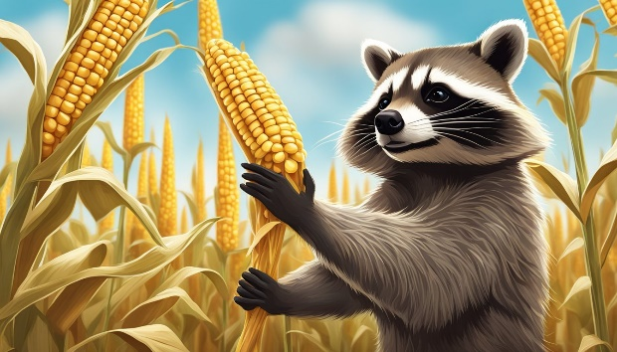The Dudley Farm sells popcorn on the cob at the Farmers’ Market, as well as sweet corn and ornamental corn in season. Visit us on Harvest Day to watch us shell, grind, and popcorn.

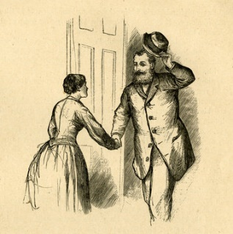**Miss Manners**

**for the 19th Century**

*Old-Fashioned Rules for Good Behavior*

Women in the Victorian Era (1837-1901)were expected to carefully follow countless social rules regarding manners and etiquette. The few noted here point out that when it comes to manners in the 19th century and Victorian social norms, there was certainly a lot to learn.

To guide the uninitiated, Thomas E. Hill compiled a list of dos and don’ts in his Manual of Social and Business Forms, first published in 1875. What follows is just a sampling of the guidance offered in that text regarding social etiquette for ladies and gentlemen

### Hygiene Etiquette (no foul bodies allowed!)

* **Bathing:** *Upon arising, take a complete bath. A simple washing out of the eyes is not sufficient. The complete bathing of the body once each day is of the utmost importance. Not more than a quart of water is necessary, preferably rainwater.*
* **Hair:**  *The head should be washed occasionally with soap and water. When the hair is inclined to be harsh and dry, a moderate application of bear’s grease or other dressing should be used.* (But first, go out and shoot a bear.)
* **Skin:** *Beware of exterior applications of cosmetics. Instead, once every two or three months, take a teaspoonful of powdered charcoal mixed with sweetened water or milk. This will prove efficacious in making the complexion clear and transparent.* (Heaven forbid if your melanin reacts to the sun and darkens the skin!)
* **Kissing:** *Upon the meeting of intimate friends, among ladies, at the private house, the kiss as a mode of salutation is yet common; but this is a custom which ought to be abolished for physiological and other reasons.*

### Social Etiquette and Manners

**Bowing:** *A gentleman should not bow from a window to a lady on the street, though he may bow slightly from the street upon*

* *vulgar manner, it is better to give a civil reply and address the person respectfully, in which case he is quite likely to be ashamed of his own conduct.*
* **Small talk:** *No topic of absorbing interest may be admitted to polite conversation. It might lead to discussion.* (We wouldn’t want that to happen!)
* **Conduct to avoid at the ball:** *No gentleman should enter the ladies’ dressing room at a ball.*
* **Card-playing:** *If possible, do not violate the rules of the game, and do not cheat. Should you observe anyone cheating, quietly and very politely call it to his attention, and be careful that you do not get excited. People who experience ill-feeling at the game should avoid playing.*
* **Marriage:** *Anyone with bright red hair and a florid complexion should marry someone with jet-black hair. The very corpulent should marry the thin and spare, and the body, wiry, cold-blooded should marry the round-featured, warmhearted, emotional type.*
* **Husbands:** *Always leave home with a tender goodbye and loving words. They may be the last.*
* **Train travel:** *People with weak eyes should avoid reading on trains, and those with weak lungs should avoid talking.*
* **Street etiquette:** *When crossing the pavement, a lady should raise her dress with the right hand, a little about the ankle. To raise the dress with both hands is vulgar and can only be excused when mud is very deep.* 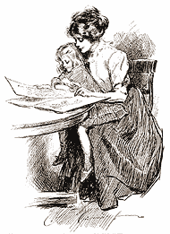

**The Dudley Farm Gift Shop**

Jerri Guadagno

***H***ello to everyone who has stopped by the Dudley Farm Gift Shop at the weekly Saturday morning Farmers’ Market.

So far this year we have welcomed many who purchased our handmade items for themselves or as a gift. Several items were crafted at our weekly “Makers Monday” gathering downstairs at the Munger Barn. We meet Monday afternoons from 1 to 3 PM, when a diverse group of ladies bring their various projects to create in community. You are welcome to join us! We are so grateful for the many donations these artists have made to the Gift Shop.

Come one and all, stop by the Dudley Farm Gift Shop, check out what we have for sale, and remember that all proceeds go to help run the Dudley Farm Museum. The items that we sell are handmade with creativity and love.

See you at the Farmers’ Market, Saturdays from 9:30 AM to 12:30 PM.

**A Letter to Great-Grandmother Kate**

Kate Zapadka

***D***ear Kate,

I'm writing this while at my favorite place, Dudley Farm Museum in North Guilford. I recently joined two other ladies in a total immersion Victorian Farmhouse experience at the museum. We engaged in chores and hobby activities similar to what you would have known as a young wife in the Wild West of Kansas in the nineteenth century.

We made bread and gingerbread and enjoyed them with soup and butter we had churned. Wool from sheep pastured on museum grounds was spun and carded. We washed laundry in tubs, hand sewed, and enjoyed books and magazines from your era.

In the archives, we looked at baby and adult clothing from the nineteenth century and examined old documents and letters.

The museum houses a small herd of sheep and we watched them being fed and moved from the barnyard to the shepherd’s vehicle… and enjoyed the chase when they escaped.

None of these experiences was easy; people in my time rarely practice the old skills, so it was all new for the three of us. The hard work was made tolerable- if not enjoyable- by being done as a team activity. I hope you had the benefit of companionship as you went about your tasks. And I wish I had known you.

Your great-granddaughter,

Kate Zapadka

**The Passage of Time**

***T***he Dudley Farm is saddened to learn of the death of two of its most active and long-time members. They will be sorely missed.

***Ray Dudley*** identified with and actively contributed to the town of Guilford throughout his life. A Guilford High School graduate, he received his undergraduate degree

from Drew University and his Master’s in teaching from Brown. Ray taught English at Daniel Hand in Madison for 38 years.

From his earliest days, Ray was part of Guilford’s farming community, starting with his family’s gardens on Clapboard Hill and his cousin’s dairy farm. He shared a large garden with his brother Mark and volunteered at the Dudley Farm Museum. Introduced to horse pulling at the Guilford Fair on the Green he won many blue ribbons with his horses in his later years.

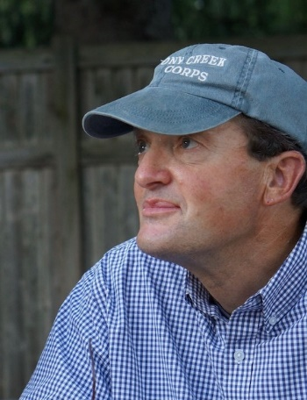

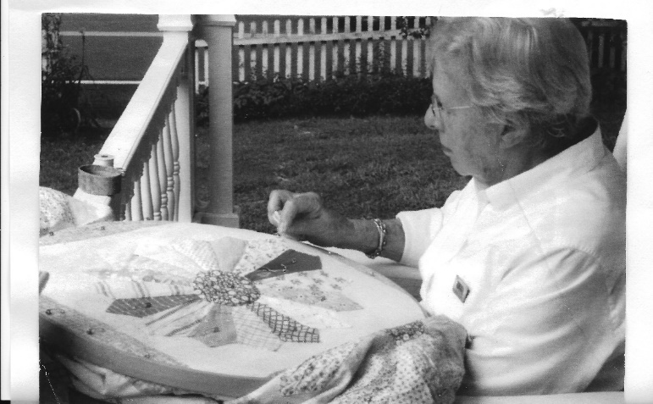Ray’s civic involvement led to his helping to found Guilford Recycling, a volunteer group associated with the Guilford Land Trust. While teaching he served for 20 years on the Conservation Commission, and in retirement was a long-time Board member of Alder Brook Cemetery. For years he maintained the grounds of the First Congregational Church on the Green as well as the grounds of the Dudley Farm Museum, where he also built and maintained their chicken coop, referred to by Board members as the Chicken Taj Mahal! Ray delivered Meals on Wheels, and was a member of Guilford’s historical associations, the Guilford Agricultural Association, and the Draft Horse Association.

***Jean Hill***  
Jean Maurer Hill died peacefully in her home on August 14, 2024, at the age of 100. Born in New Haven, CT on October 31, 1923, Jean grew up in Short Beach. Jean was the wife of the late Forrest R. Hill, who she met on a New Year's Eve blind date and married in 1948. Jean and Forrest purchased property on Durham Rd. from the Dudley family, where they built a house, raised 4 children, and spent the remainder of their lives as active members of the Guilford community. In addition to managing the home and family, Jean worked as a secretary for several local businesses, as well as the North Guilford Congregational Church, where she was a member. She also served her community by volunteering for Guilford polling stations and the Red Cross.  
Jean was well-known and admired for her talents in the art of handcraft. As an avid quilter, she won Best-in-Show at the Guilford fair and hosted a weekly quilting group in her home. Jean loved the beach, especially Block Island vacations. Jean will live on in the hearts of all those who knew and loved her; memories of her easy laugh and white Ked's sneakers, apple pies and blueberry pancakes, love of Jeopardy and solitaire, and her regular spot on the porch of The Dudley farm. Jean is survived by her daughters, Barbara Flajnik (Joseph) of Sonoma, CA, and Elizabeth Hill of Guilford, CT, son, Frederick Hill and daughter-in-law Renee of Killingworth, CT. Jean has four grandchildren, Rachel Gray Gollogly (Zarin) of San Francisco, CA, Benjamin Flajnik (Christina) of Sonoma, CA, Julia Fitzpatrick (Garrett) of San Rafael, CA, and Andrew Hill of Killingworth, CT, as well as two great-grandchildren. Jean was predeceased by her daughter, Sara Gray of Naples, FL, who died last year.

**VOLUNTEER SPOTLIGHT**

Jim Powers

***I***f you have visited the Dudley Farm House or the Quinnipiac Dawnland Museum over the past four or five years there is a good chance you have been given a tour by one of the Dudley Farm’s most active and enthusiastic docents, Monique Nemarich. Monique’s easygoing and knowledgeable manner translates wonderfully to visitors as she guides them through the story of the Dudley family and talks about what life was like in the big white farmhouse and the farm 100 years ago.

Monique was the very first person to volunteer as a docent for what is now the Quinnipiac Dawnland Museum when its earlier life as Gordon Brainerd’s Quinnipiac Museum was located in the loft of the Munger Barn. As Gordon became increasingly ill in the few years before COVID struck the area, Monique volunteered to be in the loft on Saturday mornings during the Farmers’ Market. At times she braved blistering heat in the summer and chilly or cold temperatures in the spring and fall in the unheated barn.

Like our other wonderful docents in the House and Dawnland, Monique is constantly adding to her knowledge to help make both come to life for visitors. We owe them all a tremendous amount of thanks, they are the face of the Dudley Farm every Saturday and Sunday. We owe a special thanks to Monique for her dedication to making the Dudley Farm and the Quinnipiac Dawnland Museum a place where history comes alive.

**Corn**

|  |  |  |  |  |  |  |  |  |  |  |  |  |  |  |  |  |  |  |  |  |  |  |  |
| --- | --- | --- | --- | --- | --- | --- | --- | --- | --- | --- | --- | --- | --- | --- | --- | --- | --- | --- | --- | --- | --- | --- | --- |
| J | I | X | U | R | C | O | R | N | E | D | B | E | E | F | C | B | H | J | Z | J | K | Y | B |
| Y | S | E | C | M | Y | L | X | B | D | I | A | R | B | L | B | P | S | C | I | U | C | P | U |
| Q | C | O | R | N | H | O | L | E | M | Z | F | Q | E | R | M | I | I | A | R | A | D | K | Y |
| Z | Z | F | W | F | T | A | X | R | O | R | U | G | H | J | L | P | S | Y | G | A | A | T | W |
| H | N | Q | Z | Z | E | P | B | X | R | W | F | V | E | K | B | Q | N | W | C | D | T | P | H |
| D | M | H | J | J | F | C | H | O | W | D | E | R | H | Q | A | Y | Y | A | F | V | K | S | I |
| O | C | I | Z | S | A | X | C | M | J | N | Y | E | P | P | O | T | Y | A | U | I | W | S | S |
| V | P | K | U | Y | W | M | L | G | E | G | L | P | Z | A | L | H | V | S | Y | R | U | P | K |
| K | J | U | V | N | C | O | K | X | U | A | F | H | U | S | K | O | T | F | A | M | J | F | E |
| T | O | G | J | O | B | G | R | R | F | X | L | E | F | P | K | N | V | V | H | Z | G | Y | Y |
| I | T | V | B | E | V | W | T | C | N | R | B | A | L | S | R | A | R | E | Z | A | V | J | T |
| N | Z | O | X | N | B | Q | N | M | N | V | Q | I | R | O | V | H | M | F | I | E | L | D | E |
| D | K | Z | B | X | A | K | B | Y | I | J | E | E | C | T | E | Y | S | V | L | K | G | Z | U |
| I | S | B | F | H | A | T | X | D | K | P | T | E | C | O | G | C | F | I | V | X | I | A | V |
| A | K | S | W | L | N | Z | A | D | F | T | H | C | I | I | R | Y | S | N | L | A | L | G | G |
| N | M | B | L | P | V | T | T | F | I | T | O | E | B | E | G | J | G | K | M | E | K | R | C |
| Q | G | I | N | B | F | K | H | R | N | C | M | R | A | X | V | U | E | C | B | P | R | R | J |
| M | B | J | S | R | L | X | F | I | C | U | O | M | V | C | Z | V | I | S | O | I | S | I | H |
| A | A | Y | D | E | B | U | S | Y | F | O | E | O | X | A | C | A | N | D | Y | C | O | R | N |
| Z | Q | O | K | A | I | W | W | F | M | D | B | T | F | X | A | Z | C | R | D | T | C | N | Z |
| E | G | N | R | D | O | R | I | Z | W | Q | B | P | W | Y | T | K | J | Z | S | B | H | Y | L |
| I | C | Q | B | C | M | N | X | O | S | I | N | U | I | B | H | R | F | R | O | Q | W | N | T |
| W | C | U | G | I | R | G | D | H | C | N | O | U | V | P | Z | Q | L | O | D | A | J | Q | U |
| K | B | E | S | C | A | R | C | T | F | C | B | H | E | C | E | N | A | R | T | X | T | J | E |

   maize       cob       meal       syrup       starch       muffin       corned beef       relish       creamed

fritters       maze       dog       cob pipe       whiskey       bread       chowder       silk       husk

 broom       Indian       field       rows       corn hole       cows in the corn       candy corn

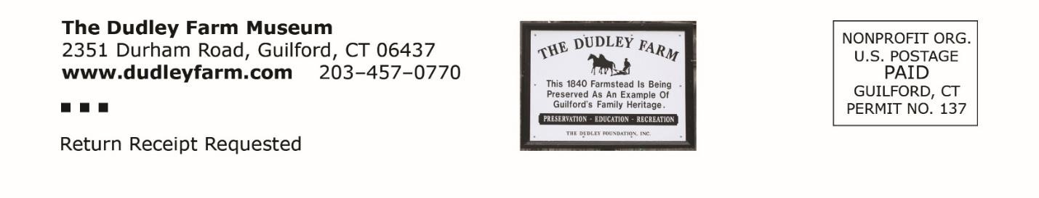

***Our Vision: “The Dudley Foundation will provide leadership to the greater community in the promotion of historic awareness and interpretation of the history of the North Guilford Community.”***

***Autumn 2024***