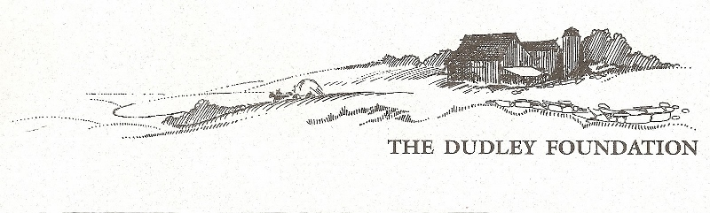Annual Report 2024

**From the Museum Director**

**Mission Statement**  
To preserve, restore and operate The Dudley Farm Museum as a late 19th century historical, educational and recreational resource to serve the general public.

***2024*** remains busy for our organization. Our website (www.dudleyfarm.com), is well-maintained by Board member Ray Guimont. Our new map, link to our audio tour and logo are all featured there, while our Facebook page helps keep the public current with over 2000 followers. (www.facebook.com/dudleyfarmmuseum). ***D***udley Farm Doings, our electronic mailing, is sent out at least monthly to 1000 subscribers, ensuring subscribers stay in touch with The Dudley Farm while reading a bit about 19th-century farm life. These word pictures about life on the farm have been very well received and are emailed to people all around the country. ***O****ur* Farmers’ Market continues to attract new folks to the Farm. Under the capable leadership of our Market Manager, Mary Taylor Murphy, flowers, craft items, and various foodstuffs are available for purchase. Know someone who would be interested in helping us expand our food offerings? Let us know. ***T***he Munger Barn event venue continues to provide the financial support needed to maintain our numerous buildings. Additional support for our operations has been received thanks to a grant from the New England Dairy and Food Council which also provided us with Miss Molly, our Marvelous Milking Cow! (Did you see her in the Guilford Parade?) ARPA Funds, administered by The Guilford Foundation, and donations from many generous individuals helped to balance our books, while interns from local colleges and universities assisted with exhibit design and Indigenous artifact identification. ***J***udy Stone encourages her gardeners, keeping the Community Garden busy, while getting help from the Guilford Garden Club to maintain our Heritage Garden. ***T***hanks to the leadership of Jim Powers and Maria Trumpler as well as the hours of support from Dudley Foundation docents, the Quinnipiac Dawnland Museum has been a terrific addition to our Museum while showcasing the story of the Quinnipiac people who inhabited this area. ***T***here is an African proverb – “slowly, slowly, you will catch the monkey in the grass.” Well, our monkey – or monkeys – are the Chase Turbine Sawmill and the Aermotor Windmill. While there *is* progress, it has been slow. But we persevere!***A picture containing text
*** ***T***hanks to the tireless efforts of Steve VanderMaelen and John Otte our workshop exhibit showcases some of the many tools used by late 19th century farmers. Did you know that Connecticut supported more than 25 toolmakers at that time? ***W***e now have *two* cows in our barn, Miss Molly, a life-size fiberglass cow that moos, and Miss Polly, a Jersey. Both can be milked and are looking forward to showing off their talents and challenging yours. Our intern, Bill Yerxa, took on the task of developing our dairy and environment exhibit to be installed in the Big Barn. Cows, stanchions, and electricity are all there – now awaiting the panels for installation.

***T***hank you for your support in ensuring that our vision will become a reality.

**Vision Statement**  
The Dudley Foundation will provide leadership to the greater community in the promotion of historic awareness and interpretation of the history of the North Guilford Community.

***W***e have continued to build on past successes to become an important part of Guilford’s historical heritage. If you have not been involved, I ask that you consider volunteering, and/or financially contributing to our organization’s many projects. There is much to do. Thank you so much. *Beth Payne*, Museum Director

**What did we do in 2024?**

***W***e saw activity “down on the Farm” before our doors opened for the season, with Dudley Farm Maple Syrup produced in our sugar house thanks to Bill Black, Jim Powers, Tom Leddy, Becky Gladych, Don Homer, Jerri Guadagno, Maria Trumpler and Mary Hotchkiss, all under the watchful guidance of Buster Scranton. People were eager to get out of their homes and enjoy some time at the Farm with an early spring wildflower walk. Guilford’s Five Museums collaborated with “Passport to Guilford’s History”, encouraging visitors to visit all five museums and enter a drawing for prizes. Families from around the state took advantage of this popular program, and winners were chosen in September. Thanks to our Events Committee several successful programs featured Museum artifacts and a well-attended foraging program. And did you help celebrate our 30th year at the concert? The Dudley Farm String Band moved into the Munger Barn when rain threatened, and the audience found their toes tapping while kids danced the night away.

***A***fter too many false alarms The Dudley Foundation is working with Shoreline Security to improve our security system – no longer will Board Members receive phone calls at 6 AM because a fire alarm is summoning the fire department or the security system has called the police! This needed but expensive improvement should be completed by the time you read this.

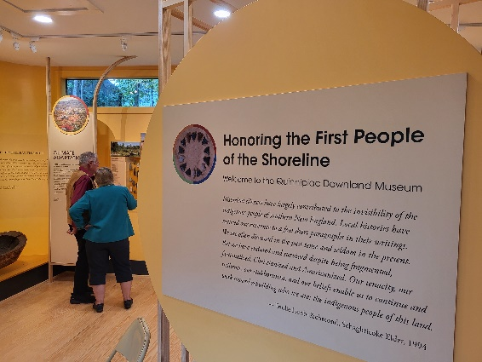***J***im Powers has been very busy speaking around the state about the history of the Quinnipiac people and assuring that the word gets out about the Quinnipiac Dawnland Museum at The Dudley Farm.

***A***s Museum Director I attended and again presented at the national conference of the Association for Living History, Farm and Agricultural Museums. This time the presentation focused on developing small agricultural exhibits using our participation in Connecticut’s MuseumMakeover project as a model.

***And* we received grants:**

Logo



** *A special thanks to Our Board of Directors***

***T***his past year was a particularly busy one for our Board, and they proved their mettle with the many challenges: grants, supply chain issues, the need to repair or replace needed mechanical systems, and so much more. They deserve all our thanks and appreciation.

***So Won’t You Consider ---***

-Giving an additional gift to our organization. As you know, there is no governmental funding, and financial contributions are needed for day-to-day operations and special projects, including the need to replace the sills under the house, finish erecting our sawmill, reconstruct our Aermotor windmill, and develop special programs and exhibits, such as our Big Barn project, “Weathering Change: Farming in Connecticut from the 19th Century into the Future”. Consider volunteering to assist with one of our projects or as a committee member. Do you enjoy working with children? And learning about North Guilford’s history? We could use more docents to help with field trips for young and old! There is much work to be done. So far almost 50 volunteers have contributed more than 2500 hours of time to the Foundation in 2024– valued at more than $80,000!-Join our Board – bring your fresh ideas to help us grow- and we’ll see you “Down on the Farm”.